Cohesion in Static Versus Dynamic Text – Investigating Logical Expansions

Ida Bergvall¹ & Anneli Dyrvold²

¹Department of education, Uppsala University Sweden, ²Department of Science and Mathematics Education, Umeå University Sweden
This paper presents how static and dynamic text elements in digital teaching materials can express textual logical cohesion in mathematics text. We analyse five items in both static and dynamic versions to explore how these formats expand the text logically. The results reveal that in the versions with dynamic functions, the reader is offered a logic that differs from the static presentation, which more often describes mathematics as given facts without allowing the reader to investigate logical connection themselves. At the same time, the dynamic functions place new demands on the reader.

Introduction
A previous study of digital teaching platforms (Dyrvold & Bergvall, 2023a) identifies rich opportunities to present relations in mathematics when dynamic and interactive functions are utilised. For instance, dynamic functions can demonstrate crucial aspects of mathematics step by step, spatially, or temporally, by allowing the student to click through information or using a video. Mathematics education does however have a long history of using the static media, and an introduction of interactive and dynamic functions do also put new demands on a reader. When dynamic and interactive functions are utilised by a reader, crucial information may be missed because such functions can demand more of a back and forth reading (Bergvall & Dyrvold, 2025). In this study we contrast static text to dynamic and interactive text focusing on the aspect of textual logical expansions to seek a deepened understanding of how a mathematics message can be expanded using different functions. A textual logical expansion (defined in Theory) is present when the second of two instances in a text is logically expanded by textual means such as the use of the word “thus” or visually. Logical expansions is a crucial part of text cohesion and therefore also of importance for reading. In the paper logical expansions do refer to such textual expansions, not to mathematics logic.

Digital modalities in mathematics education
Digital modalities have introduced new possibilities for mathematics instruction, offering a range of representational forms such as text, images, videos, tables, figures, dynamic visualizations, and interactive functions. This section outlines research on various digital resources and their potential in mathematics teaching, while also addressing limitations and challenges associated with their use.
Analyses of digital mathematics textbooks highlight how digital resources enable the integration of multimodal elements and the reorganization of mathematical information (O’Halloran, Beezer, & Farmer, 2018). Further examples of digital affordances include dynamic visualizations of mathematical relationships (Demir, 2018; Poon & Wong, 2017; Çeziktürk, 2020), drill-and-practice games (Beserra et al., 2019), automated feedback (Van der Kleij et al., 2015; Stevenson, 2017), and options to access explanations or definitions (Stevenson, 2017; Arroyo et al., 2013).
These affordances are however not used extensively in contemporary materials. Dyrvold (2022) examined the prevalence of four types of dynamic elements in Swedish digital teaching platforms, finding that theoretical sections and examples often feature low interactivity (e.g., hint boxes, text-to-speech), whereas task sections more frequently include highly interactive functions such as adaptive feedback and drag‑and‑drop activities. A socio‑semiotic analysis of seven teaching platforms (Dyrvold & Bergvall, 2023a) similarly revealed a tendency to present theoretical content and examples as written text or dynamic lectures. Interactive activities are mostly allocated to the tasks. Pepin et al. (2017) also note that task sections of teaching materials often revert to traditional formats and emphasize procedural fluency and method acquisition while videos/animations are commonly used to introduce new mathematics.

Students’ encounter with digital modalities in mathematics education
The various multimodal functions embedded in digital learning resources for mathematics offer both advantages and disadvantages for students’ engagement and learning processes. A meta-analysis about dynamic representations of mathematical objects (Moyer-Packenham & Westenskow, 2013) identified enhanced creative thinking, improved ability to direct students’ attention to relevant content, and more effective visualization of relationships between mathematical objects in response to student interaction. The analyses also suggest that such resources can foster increased student motivation and persistence when engaging with mathematical tasks, results also which revealed in analyses of students’ interaction with dynamic resources (Dyrvold & Bergvall, 2023c). Benefits of using dynamic modes is also found in an analysis of how use of a digital mathematics textbook with integrated dynamic visualisations and feedback mechanisms impacts students’ achievement, in comparison to the use of a traditional printed textbook (Brnic et al., 2024). The results indicate that both boys and girls performed better when using digital materials. The inclusion of dynamic visualisations was critical to students’ successful performance.
Another study exploring how students perform when mathematical content is presented through digital and interactive functions, as opposed to static text reveal that students with lower prior achievement in mathematics, but who were familiar with using GeoGebra, outperformed their higher-achieving peers who lacked experience with the tool (Baccaglini-Frank, 2021). Moreover, dynamic mathematics software facilitated a shift in students’ engagement from a ritualistic mode of discourse to a more exploratory form of participation. This transition supported the construction of abstract mathematical objects, as students engaged more deeply with the underlying concepts through interactive and investigative practices. Similar findings are reported by Çeziktürk (2020), about how GeoGebra is an effective tool for fostering mathematical thinking and supporting students in engaging with mathematics in ways that resemble the practices of mathematicians, including formulating and testing hypotheses through dynamic representations. Analyses of students’ reasoning indicate that the ability to make connections across multiple representations within such software plays a critical role in the development of mathematical understanding.
Digital environment offers possibilities to display mathematical objects and graphs and thereby support students’ development of covariational reasoning skills in a way not possible in print (Kertil et al., 2019). Covariation in calculus generally refers to the way two variables change together continuously or discretely. Covariational reasoning is fundamental also in elementary grades, for example in relation to rate and proportions (Gantt et al., 2023).
To understand the contributions of different modalities and thereby enable informed choices in teaching, research is needed that investigates what is conveyed when the mathematical content is presented in various ways, by means of different semiotic recourses and modalities. The impact of dynamic and interactive tools on students’ learning and engagement with mathematics remains only partially understood. Contemporary research does not offer the full picture regarding whether these functions consistently support students’ learning. Moreover, it remains unclear what specific contributions such functions make to mathematical understanding. For instance, while dynamic representations and interactive elements are often assumed to support conceptual development, there is limited empirical insight into how they do so, or what kinds of understanding they facilitate. Questions persist about whether these tools promote deeper understanding or simply increase surface-level engagement and temporary ability to solve a task. Further research is needed to gain understanding of how dynamic and interactive functions influence students’ mathematical thinking and learning. In the present study, we extend the previous work by exploring one specific aspect in depth: logical cohesive relations in static versus dynamic texts.

Aim
In this study, mathematics texts designed to represent two endpoints on a continuum, from entirely static to texts incorporating both dynamic and interactive functions, are analysed. The aim is not to identify a ‘best’ version. Rather, the study explores what the introduction of dynamic and interactive functions implies from a textual perspective. We examine what the text offers, and the potential demands it places on the reader. Accordingly, the aim of this study is to enhance understanding of the learning opportunities offered to students, by logical expansions in mathematics texts, when static versus dynamic and interactive elements are utilised. Two research questions are addressed.
RQI: How can logical expansions be offered through static and dynamic elements in mathematics text?
RQII: What kinds of demands can logical expansions in dynamic elements place on the reader?

Theory and method
This study is grounded in social semiotic theory (see Kress & van Leeuwen, 2006) highlighting how various semiotic resources can be used to express meaning in different ways. Semiotic resources include for example natural language, mathematical notation, and images. In addition to the variation in semiotic resources, digital media enables the use of these resources in different modes, the channel through which meaning is conveyed. By examining how semiotic recourses and various modalities are used to express the content, we gain understanding of the meaning offered to the reader.
All texts are characterized by cohesive relations (see e.g., Halliday & Matthiessen, 2014). In mathematical texts a facet of cohesion is networks of information between the various semiotic resources. A network is anchored by a central aspect of a concept introducing a theme relevant throughout an entire section of text. This anchoring expression can be followed by other central aspects of the same concept, constituting expansions of the concept, creating a cohesive network throughout the text. For example, the concept “per cent” can further be expanded in the text by the central aspects: “%”, an explanation using “hundredth”, and the fraction “1/100”. The theoretical understanding of expansions, which underpins this study, has been developed from van Leeuwen’s (2005) (see also Bergvall & Dyrvold, 2021). Three distinctly different types of expansions are, additive expansions (introducing new information), extending expansions (repeating information with new means or slightly reformulated) and logical expansions. We investigate logical expansions because the initial analyses revealed the most differences between static and dynamic/interactive text for logical expansions.
A logical expansion is expressed when a central aspect in the second of two instances of this aspect is justified by a reason, condition, or comparison. For example, a causal logic expansion of the concept premutation is offered when the student drags a fruit to the casket (Figure 1), because the arrangement of fruits appearing below offers the reader the message that if the number of selected fruits increases with 1, then the number of ways to arrange the fruits increases with … (visualised groups of fruits). Mathematics is a logically constructed science, and logical expansions of the text are central. However, mathematics logic and logical expansions in texts are similar but not the same; there can be both implicit mathematics logic that is not captured in the analysis and logical (textual) expansions that from a mathematics perspective is not considered as logical mathematical reasoning.

Data
The texts analysed in this study are fact boxes in five items developed in a larger research project, specifically designed to introduce new mathematics to Swedish ninth-grade students. The five items include three other parts: introduction, task, and answer options (Figure 1). For each item, there are two versions, one with a static fact box like a PDF version of a mathematical text and one with a dynamic and interactive fact box. The example shows the dynamic/interactive version of facts; depending on students dragging, the numerals changes and arrangements of fruits appear.
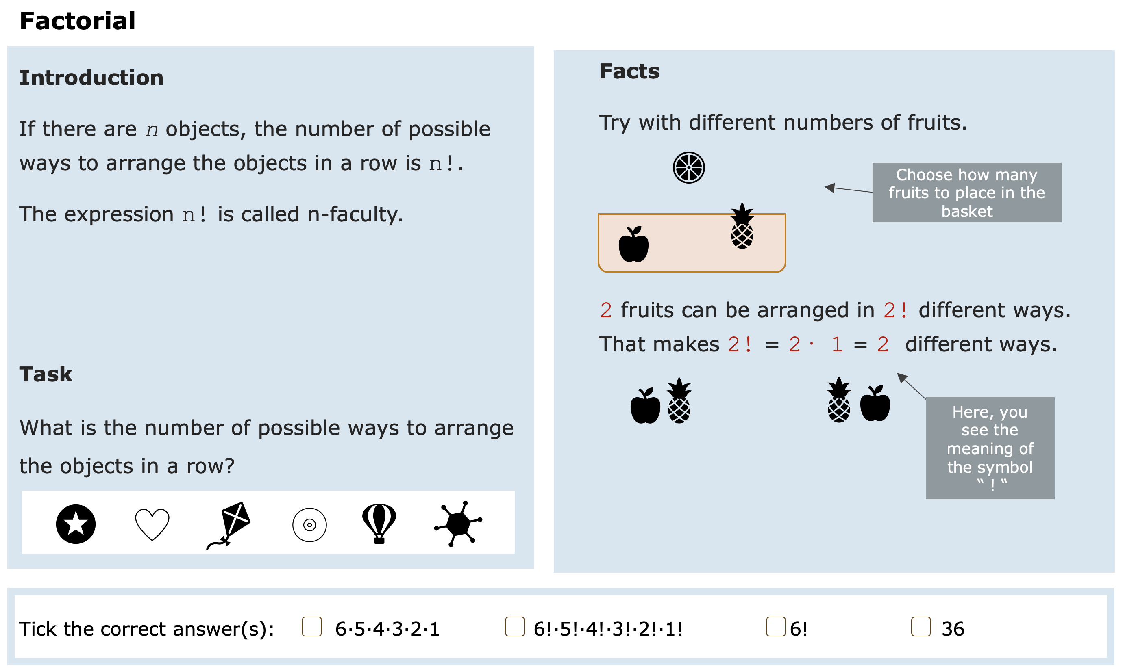
Figure 1: Arrangement of Introduction, Facts, Task, and answers in the items.
Two researchers and two textbook writers developed the items together, ensuring that the fact boxes correspond to each other as much as possible. Each fact box is designed to provide necessary information for solving tasks on five different topics (Table 1).

Item | Topic
1 | Inscribed angle theorem
2 | The sign of factor k in y = kx² related to the shape of the parabola
3 | Intersection in set theory
4 | Roots and their relation to powers
5 | Objects and permutations, introducing factorials “!”
Table 1: Content areas in items.

Implementation
The coding process started with the identification of all central aspects of the mathematical concepts in the items. In a second step, all instances of these concepts were marked. Thereafter it was noted if the central aspects express an expansion to a previously presented central aspects and what kind of expansion. Two researchers independently coded of the expansions, compared the results, and discussed some questionable cases. Finally, each pair of facts (static and dynamic/interactive) were contrasted regarding how concepts were expanded logically, with a particular focus on if and how the logical expansions were dependent on dynamism and on actions (interactive functions). A challenge in the coding process was identifying which instances expanded on others, as multimodal mathematics texts do not necessarily follow the traditional reading order. The conclusion that formed the basis for the coding, was that also multimodal texts have a structure where new information is introduced from left to right and from top to bottom (cf. Kress & van Leeuwen, 2006).

Result
The analysis reveals that in static versions of the investigated items, logical expansions are less common, but if present, directly accessible without requiring any active actions from the learner. In contrast, dynamic or interactive media make logical expansions explicit through user interaction. When the learner performs an action—such as manipulating an object—this not only affects the object itself but also triggers changes in related elements. In cases where these resulting changes occur on another instance of a central aspect; they have been identified in the analysis as a logical expansion that emerge through engagement with the material. As the visual representation shifts, multiple logical expansions may become apparent. However, it is the learner’s responsibility to initiate the interaction and subsequently interpret the relationships between central aspects in the elements. Consequently, logical expansions in dynamic media are often offered implicitly, placing cognitive and interpretative demands on the learner.
An answer to RQI–II is thus that a difference between how logical expansions occur in static versus dynamic/interactive texts is that in the latter, the occurrence of logical expansions is often contingent on the reader’s engagement.
The analysis revealed that only three of the five analysed items contained logical expansions in both the static and dynamic versions of the facts. Two of the items (2 & 5, Table 1) exhibited logical expansions in both versions of the facts. In the other three facts (item 1, 3, & 4, Table 1), there are no logical expansions present in the static version of the facts. Instead, the mathematics is in these facts presented as statements and other expansions than logical ones are used to make the text cohere. We present one example of an item with logical expansion exclusively in the dynamic version, and one example of an item with logical expansions in both versions to allow for a comparative discussion of how such expansions are manifested across static and dynamic texts.

Logic expansion dynamic/interactive text
The difference between static facts with no logical expansion and dynamic/ interactive facts with several logical expansions is demonstrated by the two versions of facts about set theory and the concept intersection. In the static version, there is an intricate path of information, but no logical expansion. Several logical expansions of the concept intersection are however offered in the dynamic/interactive version of the facts when a change in the intersection displayed in the image also leads to changes in the symbolic expressions. These expansions are dependent on the learner dragging, and thereby changing set B, while noticing the change of objects in B and simultaneously the change in the intersection (see the red letters in Figure 2). In the fact box, a logical expansion of the concept interception is shown by illustrating how a change in the intersection displayed in the image also leads to changes in the symbolic expressions “A∩B= …”.

 | 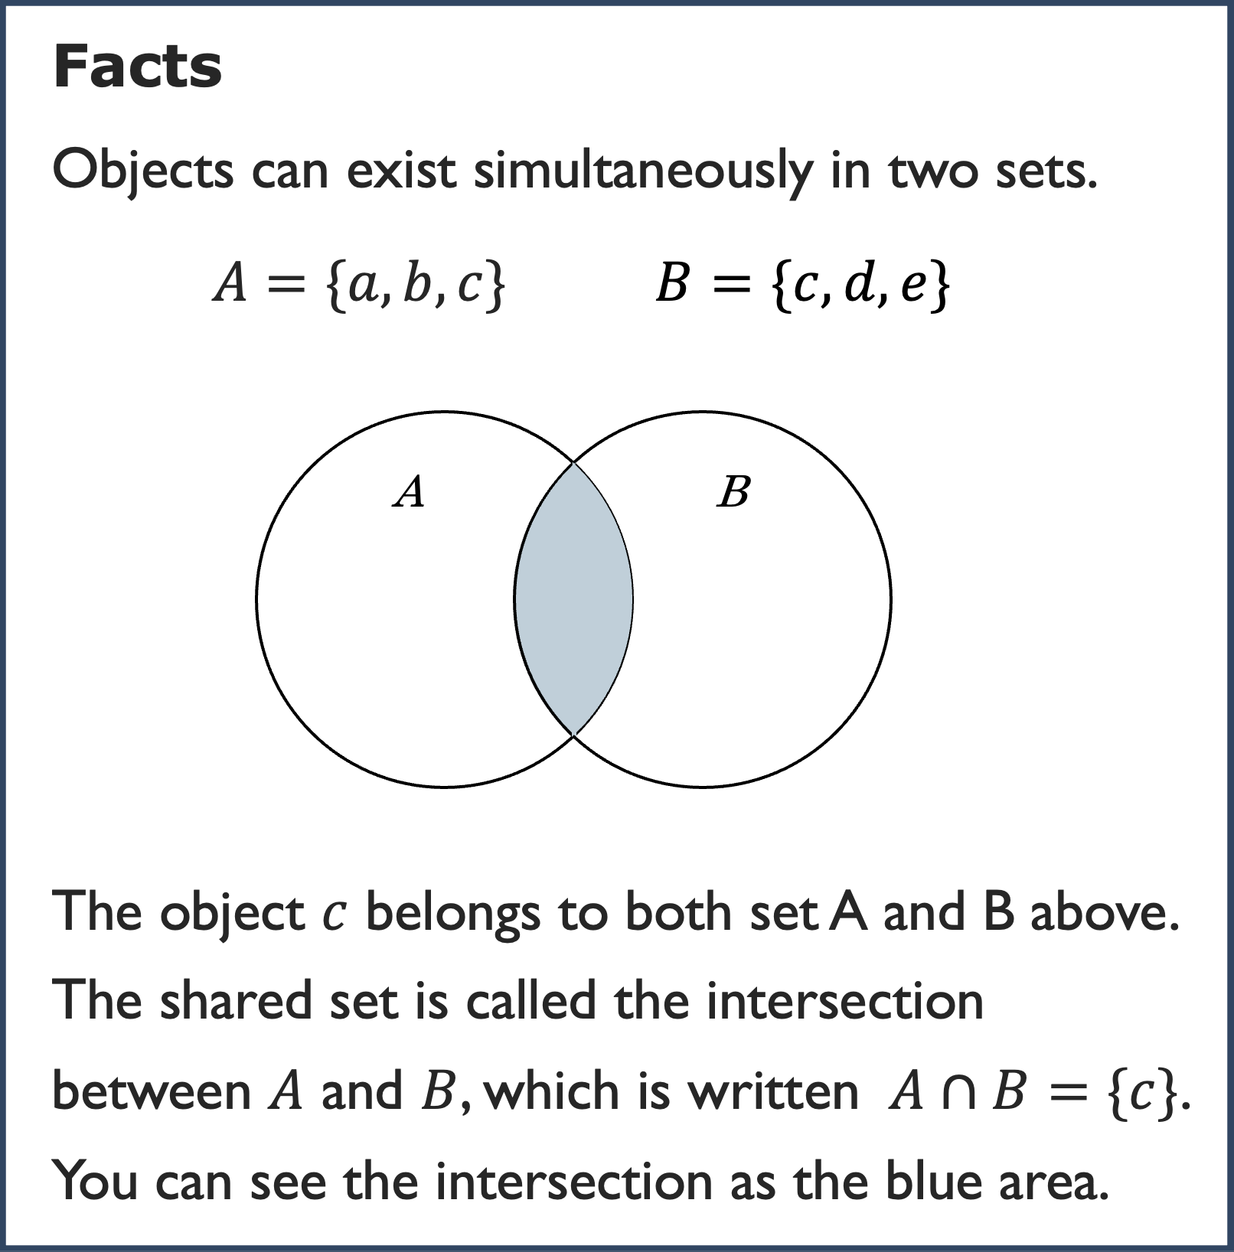 | 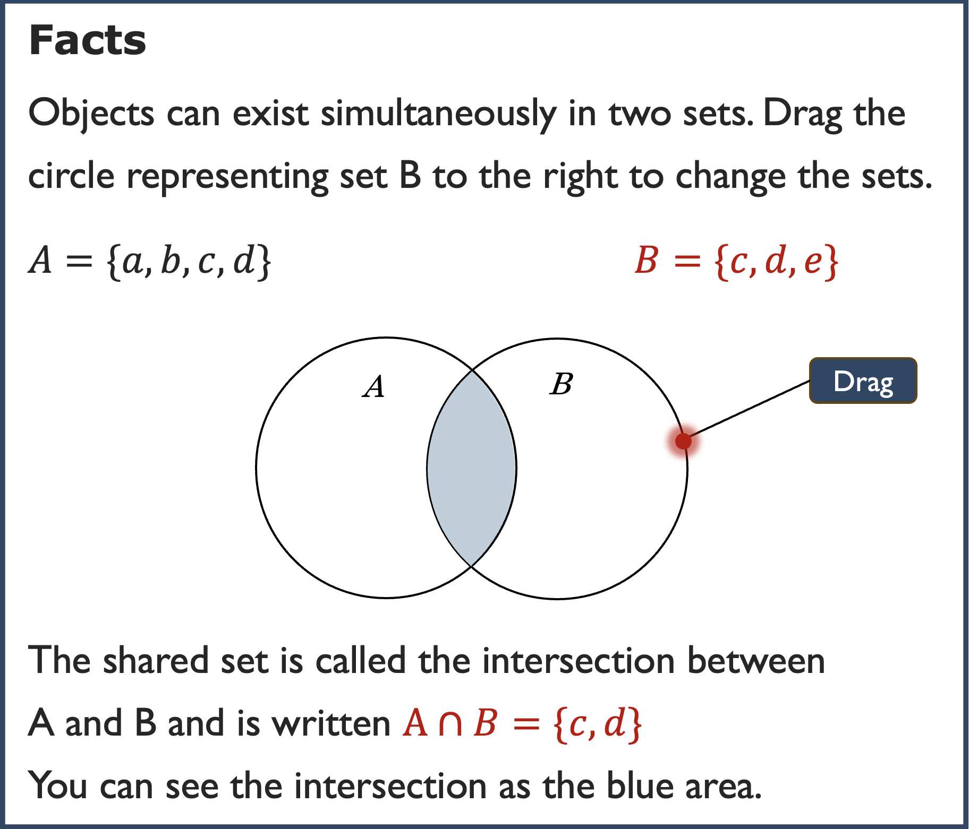
Figure 2: Facts on set theory in static and dynamic/interactive versions.

Logic expansion expressed also in static text
The second case is when both the static and dynamic versions of the facts include one or more logical expansions. Recall from the summary that in the dynamic and interactive versions of all items the facts consistently offer logical expansions, and almost all these expansions are dependent on the readers’ acts. The following section presents an examination of the logical expansions in item 2. The facts in this item offer information about the relationship between the shape of the graph of a quadratic function and the coefficient of the x² term (Figure 3).

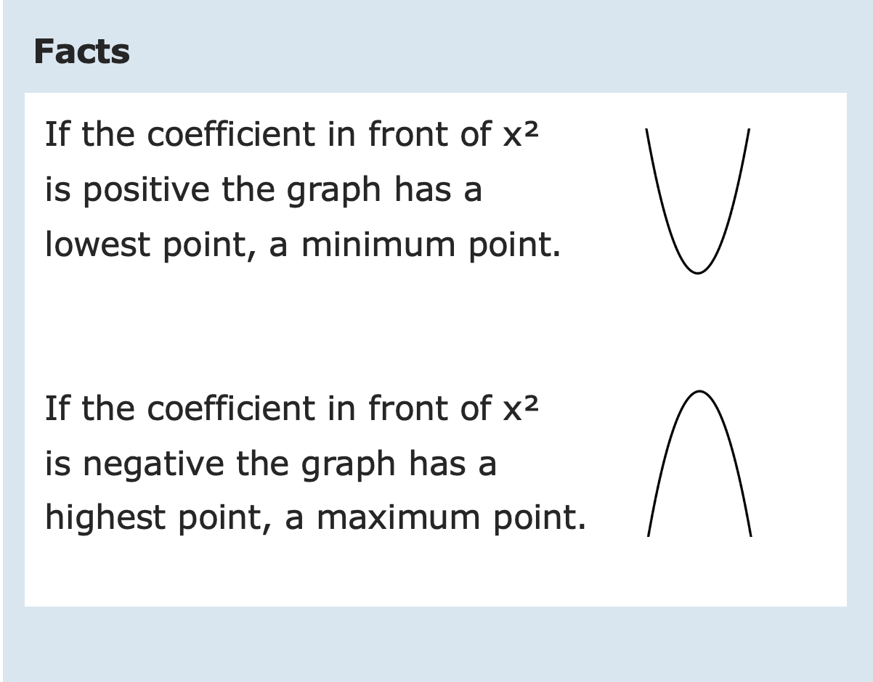 | 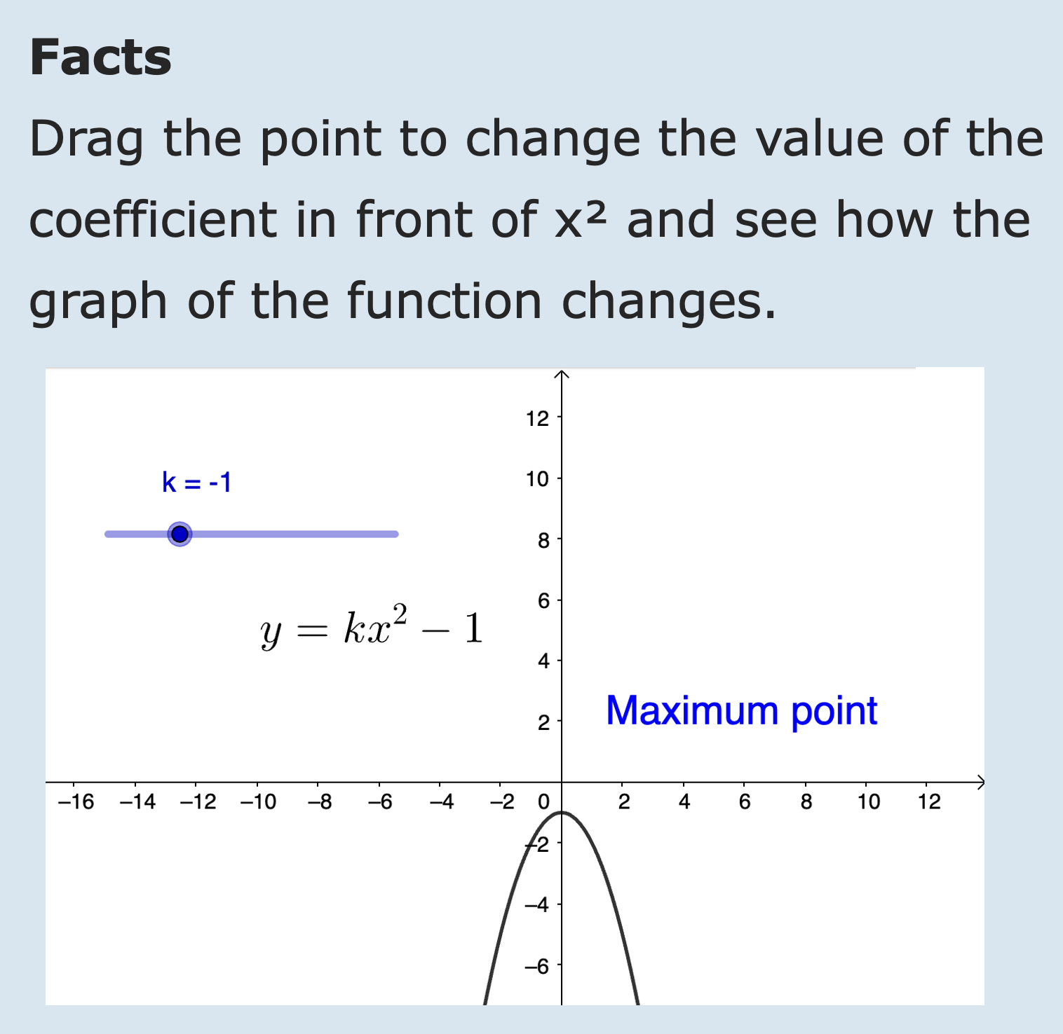
Figure 3: Facts on quadratic functions in static and dynamic versions.
In the static version, a logical expansion of the concept quadratic function is expressed via the central aspects “minimum point” and “maximum point” and conveyed through a conditional expression: “if the coefficient preceding x² is…”. This condition constitutes a logical expansion of the central aspects, as it explicates the relationship between the sign of the coefficient and the resulting shape of the graph; specifically, whether the graph has a minimum or a maximum point. Thus, in the static version, logical expansions are provided in two distinct instances, explicitly and without necessitating active engagement from the reader. In contrast, the dynamic version invites the reader to interact by dragging a point on a slider. This interactive element enables the disclosure of up to five distinct instances of logical expansion related to the concepts of minimum and maximum points. However, the realisation of these expanded concepts is contingent upon the reader’s active participation. Without such engagement, the additional layers of logical expansions remain inaccessible.

Conclusion and discussion
The results of the current study highlight how the use of dynamic/interactive features in the presentation of mathematical facts entails increased possibilities for the reader to access a coherent message via logical expansions. By means of the in-depth analysis of the logical expansions that makes the text cohere, the results enrich understanding from previous research showing the value of dynamic visualisation of mathematical relations (e.g., Çeziktürk, 2020; Demir, 2018; Poon & Wong, 2017).
The results also point out that the potential benefits of the dynamic and interactive means are dependent on the readers active use of them. Thus, dynamic/interactive elements provide opportunities to support learning, but they do also introduce new demands on the reader. Furthermore, the reader must grasp how central aspects in elements emerging dynamically in the text are related, to benefit from different logical expansions offered. If a concept is expanded logically due to actions taken, but the reader does not make the connection in reading, the dynamism does not add much value. On the other hand, readers of static texts must also make connections to benefit from logical expansions of central aspects. Consider, the static version of the facts about maximum and minimum point (Figure 3). Here, the logical relationship between the conditional “if” statement and the corresponding shape of the graph must be followed and interpreted. In contrast, when engaging with the dynamic version (Figure 3), the reader can interact with the content by dragging a slider to observe how the graph flips between a maximum and a minimum as the parameter k shifts from negative to positive values. While dynamic formats can offer richer opportunities for exploring logical relationships, static representations provide immediate access to the core facts. The choice of mode may depend on the student’s position within the learning trajectory and whether an exploratory activity is pedagogically appropriate at that stage.
In all but one of the analysed items, the one defining concepts in set theory, covariational aspects are present. The development of covariational skills are as fundamental (Gnatt et al., 2023) and recent research has highlighted the potential of digital environments to support students’ covariational reasoning through dynamic visualizations of mathematical objects and graphs (Kertil et al., 2019). The current study provides a possible explanation by pointing out the importance of logical expansions present in the dynamic and interactive texts.
Mathematics curriculum resources often present new content in a linear fashion, while opportunities to explore mathematical relationships and patterns are typically found in tasks (e.g., Dyrvold, 2022; Pepin et al., 2017). This structure implicitly positions the student as a passive receiver of mathematics posed by a mathematician, suggesting that meaningful exploration by the student is only possible after a formal presentation of the mathematical foundations. Regarding the demands to actively manipulate components in the mathematics text, we suggest that offering mathematical facts in interactive and dynamic ways can reposition the student as an active practitioner. When students engage deeply with mathematical ideas and construct understanding through logical extensions of core concepts, they move beyond passive reception. Previous research has shown how dynamic visualisation of mathematical relations can direct students’ attention to relevant content and enhance their willingness to engage in mathematics (Moyer-Packenham & Westenskow, 2013). Çeziktürk (2020) similarly emphasizes how dynamic software can transform students into active participants, engaging in mathematical reasoning akin to that of mathematicians, which is also of importance regarding the view on mathematics and self that is conveyed to students.

References
Arroyo, I., Burleson, W., Tai, M., Muldner, K., & Woolf, B. P. (2013). Gender differences in the use and benefit of advanced learning technologies for mathematics. Journal of Educational Psychology, 105(4), 957–969. https://doi.org/10.1037/a0032748
Baccaglini-Frank, A. (2021). To tell a story, you need a protagonist: how dynamic interactive mediators can fulfil this role and foster explorative participation to mathematical discourse. Educational Studies in Mathematics, 106(2), 291–312. https://doi-org.ezproxy.its.uu.se/10.1007/s10649-020-10009-w
Bergvall, I., & Dyrvold. A. (2021). A model for analysing digital mathematics teaching material from a social semiotic perspective. Designs for Learning, 13(1), 1–7. https://doi.org/10.16993/dfl.167
Bergvall, I., & Dyrvold, A. (accepted). Timeline analysis of student reading – exploring eye Tracking data.
Beserra, V., Nussbaum, M., & Oteo, M. (2019). On-task and off-task behavior in the classroom: A study on mathematics learning with educational video games. Journal of Educational Computing Research, 56(8), 1361–1383. https://doi.org/10.1177/0735633117744346
Brnic, M., Greefrath, G., & Reinhold, F. (2024). Working with digital textbooks or printed materials: A study with boys and girls on conditional probability. ZDM, 56(4), 559–572. https://doi.org/10.1007/s11858-023-01543-x
Çeziktürk, O. (2020). Understanding functional dependency on dynamic geometry systems (DGS): Napoleon and von aubel theorems on geogebra. International technology and education journal, 4(1), 15–21.
Demir, M. (2018). Effects of virtual manipulatives with different approaches on students’ knowledge of slope. Journal of Interactive Learning Research, 29(1), 25–50.
Dyrvold, A. (2022). Missed opportunities in digital teaching platforms: Under-use of interactive and dynamic elements. The Journal of Computers in Mathematics and Science Teaching, 41(2), 135. https://doi.org/10.70725/440859vgdrsh
Dyrvold, A., & Bergvall, I. (2023a). Digital teaching platforms: the use of dynamic functions to express mathematical content. Scandinavian Journal of Educational Research, 68(5), 861–877. https://doi.org/10.1080/00313831.2023.2196555
Dyrvold, A., & Bergvall, I. (2023c). Computer-based assessment in mathematics: Issues about validity. LUMAT, 11(3), 49–76. https://doi.org/10.31129/LUMAT.11.3.1877
Gantt, A. L., Paoletti, T., & Corven, J. (2023). Exploring the Prevalence of Covariational Reasoning Across Mathematics and Science Using TIMSS 2011 Assessment Items. International Journal of Science and Mathematics Education, 21(8), 2349–2373. https://doi.org/10.1007/s10763-023-10353-2
Gracin, D. G., & Krišto, A. (2022). Differences in the Requirements of Digital and Printed Mathematics Textbooks: Focus on Geometry Chapters. Centre for Educational Policy Studies Journal, 12(2), 95–117. https://doi.org/10.26529/cepsj.1285
Halliday, M A K., & Matthiessen, C. M. (2014). An introduction to functional grammar (4 ed.). Arnold. https://doi.org/10.4324/9780203431269
Jacinto, H., & Carreira, S. (2021). Digital tools and paper-and-pencil in solving-and-expressing: how technology expands a student’s conceptual model of a covariation problem. Journal on Mathematics Education, 12(1), 113–132. https://doi.org/10.22342/jme.12.1.12940.113-132
Kertil, M., Erbas, A. K., & Cetinkaya, B. (2019). Developing prospective teachers’ covariational reasoning through a model development sequence. Mathematical Thinking and Learning, 21(3), 207–233. https://doi.org/10.1080/10986065.2019.1576001
Kress, G., & van Leeuwen, T. (2006). Reading images: The grammar of visual design (2nd ed.). London: Routledge. https://doi.org/10.4324/9780203619728
Moyer-Packenham, P. S., & Westenskow, A. (2013). Effects of virtual manipulatives on student achievement and mathematics learning. International Journal of Virtual and Personal Learning Environments, 4(3), 35-50.
O’Halloran, K. L., Beezer, R. A., & Farmer, D. W. (2018). A new generation of mathematics textbook research and development. ZDM, 50(5), 863–879. https://doi.org/10.1007/s11858-018-0959-8
Pepin, B., Gueudet, G., & Trouche, L. (2017). Refining teacher design capacity: Mathematics teachers’ interactions with digital curriculum resources. ZDM, 49(5), 799–812. https://doi.org/10.1007/s11858-017-0870-8
Poon, K. K., & Wong, K. L. (2017). Pre-constructed dynamic geometry materials in the classroom-how do they facilitate the learning of “similar triangles”? International Journal of Mathematical Educa-tion in Science and Technology, 48(5), 735–755. https://doi.org/10.1080/0020739X.2016.1264636
Stevenson, C. E. (2017). Role of working memory and strategy-use in feedback effects on children’s progression in analogy solving: An explanatory item response theory account. International Journal of Artificial Intelligence in Education, 27(3), 393-418. https://doi.org/10.1007/s40593-016-0129-5
Van der Kleij, F. M., Feskens, R. C. W., & Eggen, T. J. H. M. (2015). Effects of Feedback in a Computer-Based Learning Environment on Students’ Learning Outcomes: A Meta-Analysis. Review of Educational Research, 85(4), 475–511. https://doi.org/10.3102/0034654314564881
van Leeuwen, T. (2005). Introducing social semiotics. Routledge.

