Mathematical Self-Efficacy and Test Anxiety: Mediating Effects of Rehearsal, Metacognition and Effort on Achievement

Jimmy Karlsson

Department of Mathematics and Computer Science, Karlstad University
This presentation presents ongoing work exploring relationships between mathematical self-efficacy and test anxiety, and how these factors influence mathematical achievement via rehearsal strategies, metacognition and effort. According to Bandura’s (1997) social cognitive theory, self-efficacy is associated with more efficient study strategies and effort, whereas mathematics anxiety (Dowker et al., 2016) may lead to avoidance behaviours that hinder mathematics development. Understanding how these factors might mediate through learning behaviours is of importance to understand how these could influence mathematical achievement.

Method
The sample consists of upper secondary students (n = 1005) studying their second mathematics course from social science and science tracks. Students completed a Likert-style questionnaire in their final month of the course prior to their national tests. Measures included; mathematics self-efficacy, test-anxiety, rehearsal strategies, metacognition and perceived effort. Mathematics achievement was measured by the final score on the national test. A partial least square structural equation modelling approach (Hair et al., 2021) was used to test a multiple mediation model.

Results
The explored model explained 42% of variance in mathematics achievement and between 15-20 % of rehearsal, metacognition and effort variables. Self-efficacy positively predicts achievement both directly and indirectly via metacognition and effort suggesting a complementary partial mediation (VAF = 0.14). Rehearsal strategies mediated a negative pathway, suggesting a counterproductive relationship with achievement. In contrast, relating to test anxiety, the model suggests a mediation mainly via rehearsal strategy with a negative relationship towards achievement with no significant direct relationship (VAF = 0.838).

Table 1. Direct and indirect relationships between self-efficacy and test-anxiety on mathematical achievement.
Path | β | 95% CI
SelfEff → Rehe → MathAch | -0.062 | [-0.088, -0.039]
SelfEff → Meta → MathAch | 0.061 | [0.030, 0.092]
SelfEff → Eff → MathAch | 0.080 | [0.048, 0.113]
SelfEff (Total indirect) | 0.078 | [0.044, 0.112]
SelfEff (Direct) | 0.488 | [0.435, 0.539]
Anx → Rehe → MathAch | -0.113 | [-0.144, -0.083]
Anx → Meta → MathAch | 0.027 | [0.012, 0.045]
Anx → Eff → MathAch | 0.027 | [0.012, 0.045]
Anx (Total indirect) | -0.058 | [-0.088, -0.030]
Anx (Direct) | -0.023 | [-0.080, 0.036]

Figure 1. Explored model connecting self-efficacy and test-anxiety via rehearsal, meta-cognition and effort on achievement.

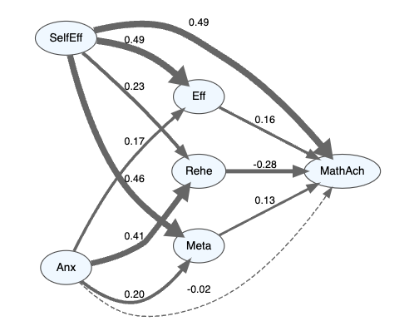
These findings highlight the importance of fostering self-efficacy and metacognitive engagement and the counterproductive use of rote rehearsal strategies for mathematics learning. Further potential implication will be discussed during the presentation.

References
Bandura, A. (1997). Self-efficacy: The exercise of control. W. H. Freeman.
Dowker, A., Sarkar, A., & Looi, C. Y. (2016). Mathematics Anxiety: What Have We Learned in 60 Years? Frontiers in Psychology, 7. https://doi.org/10.3389/fpsyg.2016.00508
Hair, J. F., Hult, G. T. M., Ringle, C. M., Sarstedt, M., Danks, N. P., & Ray, S. (2021). Partial Least Squares Structural Equation Modeling (PLS-SEM) Using R: A Workbook. Springer International Publishing. https://doi.org/10.1007/978-3-030-80519-7
Ray, S., Danks, N., & Calero Valdez, A. (2021). SEMinR: Domain-Specific Language for Building, Estimating, and Visualizing Structural Equation Models in R. SSRN Electronic Journal. https://doi.org/10.2139/ssrn.3900621

