Dilemmas using digital textbooks when learning math
Birgit Gustavsson and Yvonne Liljekvist
Karlstad University
This presentation will present and discuss findings from a project which is based on an extensive video ethnographic research project using cameras and screen recordings in upper secondary classrooms to follow teachers' and students' use of a learning platform (Nilsberth et al., forthcoming). The platform includes different kinds of teaching resources, including the textbook, and becomes a base for subject transformation. The conditions that emerge in its use uncover what mathematics learning is enabled in such kind of digitalized teaching environment. We will present a case from one student’s work to display some dilemmas that arise in this learning environment when working with a digitalized textbook. The textbook is nested in the learning platform. Each task in the textbook generates points if you enter the correct answer. If the student is unsure, they can look at a hint, but then they get fewer points. If they look at the proposed solution, they get no points.

Analysis procedure
In the analysis of the video and screen recordings we first made a transcript of the actions taken by the student. Then we analysed sequences of the student’s activities using the theoretical lens of Duval (2017) to describe the learning process.

The situation
The student in focus struggles with a task (see Table 1) and how to write the answer and get it accepted in the digital book.
Table 1. The task, and description of clues the student can use if she chooses
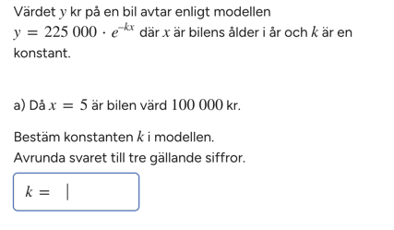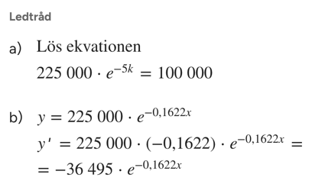
The student writes in her notebook and uses the calculator. She enters k= 0.833 in Noteflex, and it becomes marked in red (wrong). The student looks at her notes and enters 0.83, which is also marked in red. ‘No’ she says and sighs. She turns the page in her notebook and continues to write and calculate on the calculator. Enters 0.067, which is marked in red. Enters 0.0674, which is marked in red. She mumbles ‘I would like to say that it's correct… I feel’. The student looks at her calculations on paper and the screen. ‘But is it…’, she says, and tests -0.067, which is wrong, then she tests -0.0674, which is also wrong. She sighs heavily. Looks at her notes again and raises her hand.

Analysis and dilemma
According to Duval (2006) the learning process of mathematical thinking involves two types of transformations: treatments and conversions. Treatments are defined as transformations within one register, such as rephrasing or solving an equation using algebraic signs and symbols. Conversion, which is seen as a more challenging process, is defined as a transformation where the register changes, such as going from an algebraic to a graphic representation of a function, while maintaining the same conceptual reference, that is, keeping the mathematical meaning of the object. Registers are a semiotic system that permits the transformation of representations (Duval, 2006, p.111). Duval (2006) divided registers into two groups, monofunctional and multifunctional. Registers that enable mathematical processes such as algorithms (e.g. manipulations of algebraic expressions) are described as monofunctional registers. Semiotic systems that can be used for various cognitive functions, such as awareness and communication which mathematical processes cannot be made into algorithms are called multifunctional registers.
The task is about solving an equation. When the student tries different answers, both positive and negative, she works in the symbolic register. This means she is doing a treatment since she is working in one register only. In this task the clues did not invite the students to make a conversion, as the clue and solution was only written in algebraic form. This means that the student has fewer opportunities to engage in learning processes supporting more challenging mathematical thinking. She does not look at any hints or proposed solutions – she doesn't lose any points.
The analysis indicates that digital tools may shift students’ attention from mathematical reasoning to the procedural demands of interacting with the system. This displacement reflects a semiotic reorientation in which the technological format of the response becomes the locus of activity, while the underlying mathematical structures remain underexplored.
These findings highlight a critical tension within ‘platformisation’ of education: although digital tools promise to expand the range of representations and provide immediate feedback, they also risk narrowing students’ engagement to surface-level interactions. When such challenges remain unnoticed by teachers, opportunities for fostering deeper reflection and conceptual understanding are further constrained.

References
Duval, R. (2017). Understanding the mathematical way of thinking – The registers of semiotic representations. Springer. https://doi.org/10.1007/978-3-319-56910-9
Nilsberth. M., Gustafsson, B., Wendell, J., Liljekvist, Y., Olin-Scheller, C., & Samuelsson, J. (forthcoming). Subject traditions and the role of digital platforms in upper secondary education. A comparative study.

