Designing and validating a test for the assessment of Algebra-Monday

Julia Tsyganª, Ola Heleniusª, Simon Skau^{b} & Linda Marie Ahlª

ªUniversity of Gothenburg, ^{b}Karlstad University
We report on the design and validation of a 34-item algebra test intended as an outcome measure for Algebra Monday, a long-term, structural-algebra intervention. The test design operationalizes algebra as structure, operations on symbols, and functional thinking, aligning the conceptualization of algebra with the intervention focus of Algebra Monday. Administered in regular eighth- and ninth-grade lessons from May to June 2025, the instrument demonstrated good reliability, appropriate difficulty coverage, and minimal construct-irrelevant variance. These findings support its use for evaluating Algebra Monday's effectiveness at the group level and point to opportunities for further research on the nature of students’ algebra difficulties and on validation of tests used in intervention studies.

Introduction
Algebra is a major constituent of mathematics. It has historical roots in arithmetic calculations involving unknown quantities. In the modern era, algebra denotes the study of abstract systems in the form of algebraic structures. In school, algebra has traditionally played a significant role in secondary education, often serving as a gatekeeper that marks the point at which students either gain access to advanced mathematical studies or begin to disengage from the subject. For a few decades, research in mathematics education has therefore focused on early algebra as a way of fostering algebraic thinking already in the early grades, hopefully making the transition into formal algebra in secondary education less harsh (Kieran 2004).
Research on school algebra and early algebra has traditionally focused on students' (mis)understandings of algebraic concepts. Additionally, complex frameworks are presented to help understand early algebra and algebraic thinking. Some of these frameworks have also served as the basis for systematic intervention work. Notably, the work of Blanton and colleagues, who built upon an algebra framework developed by Kaput (2008), resulted in a new framework. Blanton et al. included the components of generalized arithmetic, equivalence, expressions, equations, and inequalities, and functional thinking (Blanton et al., 2015). The group then moved on to conduct a series of interventions from a K-6 perspective, with the randomized controlled trial of the group's 3-5 intervention, involving approximately 3,000 students, being the most notable effort (Blanton et al., 2019). Unfortunately, a follow-up study in grade 6 revealed that the advantage gained by the experimental group in grade 5 had vanished one year later, when a retention study was conducted (Stephens et al., 2021).
In an effort to enhance the long-term positive effects of an increased algebra focus, we have designed the project Algebra Monday. On Algebra Mondays, all teachers from K (6-year-olds) to 9 (16-year-olds) teach specifically designed algebra lessons once a week, not only for a specified number of weeks, but indefinitely. In each participating municipality, we first work with pilot teachers for a minimum of 20 weeks. These pilot teachers later act as facilitators in collegial collaborations (Roesken-Winter et al., 2021).
In Algebra Monday, we are particularly interested in promoting structural algebraic or arithmetic reasoning. By algebra as a structure, we mean ways of discovering, explicating, symbolizing, and using general relationships among, primarily arithmetic, operations (e.g., Section 4.2.2 in Kieran, 2018a). Examples include knowledge that $a⋅b=c$, $a=c/b$, and $b=c/a$ will all hold simultaneously (unless zeroes are involved). Since this category of algebra cuts across several of, for example, Blanton’s categories, we constructed an algebra framework of our own that we will briefly mention here, with three categories in addition to the main category algebra as structure.
Algebra as operations on non-numeric symbols concerns operations on symbols that represent numerical entities but are not themselves numerical symbols. This involves typical solutions of linear equations. We also consider tasks like $8+_=3$ to belong in this category, as well as tasks such as simplifying $4a^{3}+4a+2a^{3}+3a$.
Algebra as variables and functional thinking. Functional thinking is centered around using a symbol that can stand for any number (for which the function is defined), i.e., function as a variable. Functional thinking also includes graphical representation of covariation between variables. We also include modeling, i.e., when a function is created to represent some phenomenon, in the functional thinking category.
Algebra as patterns. Working with figural or geometric patterns has been proposed as a way to get acquainted with certain forms of algebraic thinking. Tasks in this class typically involve continuing and representing growing or repeating patterns (section 4.2.3 in Kieran, 2018b). This category is not a main priority in Algebra Monday because we do not see proficiency with pattern work as generative for other algebraic proficiency in the same way as we see algebra as structure as generative. This is a design hypothesis we will not delve deeper into here. For more information on the four categories above, including how they are currently represented in Swedish textbooks, see Helenius & Ahl (2024).
The functioning of Algebra Monday will be evaluated mainly by its effects on students’ algebra knowledge development. For this we need a test. There are mandatory national tests in Sweden in grades 3, 6, and 9, which will also help assess the effectiveness of Algebra Monday. These tests are, however, not algebra specific, and individual tasks cannot be shared openly, meaning they are of limited use for sharing research results. In targeted interventions such as that of Blanton et al. (2019), researchers may design their own assessments based on pre-existing assessments and may put them through various validation processes such as establishing reliability and ascertaining item difficulties. To our knowledge, there is little or no research on or recommendations for how such validation of test use for intervention research are done.
In this paper, we report on the design of an algebra test for grade 8 and 9, intended for evaluating the Algebra Monday intervention. Beyond this specific purpose, however, we hope to use it as an illustration through which to initiate a conversation with the wider mathematics education research community about how we design instruments for ascertaining the efficacy of our innovations, and how the interpretation and use of such instruments may be validated. Additionally, the test is made available upon request in the hope that other researchers and teachers may find it useful.

Design
We had two design purposes. First, we wanted the test to distinguish between algebra abilities in a population of Swedish 8th- and 9th-grade students who had not received any special treatment. Second, we wanted the test to measure aspects of algebra teaching that we were focusing on in our intervention, Algebra Monday but we were not trying to presuppose cognitive subconstructs that can form the basis for latent variables in an assessment, as Zhang et al. (2018) do. In addition, we included items that had either been proven in previous tests or were otherwise well-known in the mathematics education community. For example, the task $14-5=_+7$ is a well-known type of task in the mathematics education research literature, which tests a relational understanding of the equal sign. There are known typical errors that are helpful when designing multiple-choice items. The proportion of pupils of different ages that can correctly handle this task is well known both internationally and in the Nordic perspective (see Opsal & Topphol, 2023, for an overview). Using established tasks like this also makes it easier to build a future discussion based on previous research. In this limited format, we cannot describe the origins of all items, but several tasks are related to the following references (Hackenberg & Sevinc, 2022; Hilton et al., 2013; Niss & Jankvist, 2013). A few tasks also come from older national tests for grade 9 in Sweden.
The test was trialed in two schools during March and April 2025, with 68 students ranging from grade 7 to the third course in upper secondary school. Based on this pilot trial, 11 questions were removed to make the test shorter, based on low point-biserial correlation with the overall test result, inappropriate difficulty level, and technical difficulties in the testing platform. Moreover, test questions were reordered by difficulty. While the initial test consisted of 45 questions, the final test contained 34 questions.
We based the test construction loosely on the three focused categories in Algebra Monday: algebra as structure, as operations on non-numerical symbols, and as variables and functional thinking. Table 1 shows the distribution of tasks between the three categories. 26 of the 34 items were multiple-choice and had one option I don't know which was included to avoid students guessing. A reason to have an open answer format on 8 items was that we wanted to avoid trial and error type solutions for some equations type items. A test blueprint is presented in Table 1.

Category | Target skills | Examples | Number of items
Structure | General arithmetic facts, such as $\frac{m}{m}=1$ | What should be on the empty line?  $$a+b+_=a+c$$ | 15
Functional thinking | Using algebra to model worldly situations | The blue flower’s height (B) is $\frac{2}{5}$ of the red flower’s height (R).  Which equality is true? | 8
Non-numeric symbols | Operations on variables | Solve the equation  $$x-1=3x+5-8x$$ | 11
Table 1. Test Blueprint.
The test contains groups of items within which items will likely appear quite differently difficult to typical students. According to the design hypothesis of Algebra Monday, students who have experienced teaching focused on structural relationships should instead see many of these items as variants of the same task, in the sense that a unified principle can be used to deal with them. For example, we strongly advocate that operations often described as simplifying or expanding fractions should be understood via the neutral element in multiplication, in the form of $m/m=1$: simplifying is always done by factorising, identifying a common factor $m$ in numerator and denominator, and then removing $1=m/m$. So, the tasks in Figure 1 should differ markedly in difficulty for standard students but be more similar in difficulty for Algebra Monday students, according to the hypotheses behind the Algebra Monday intervention.
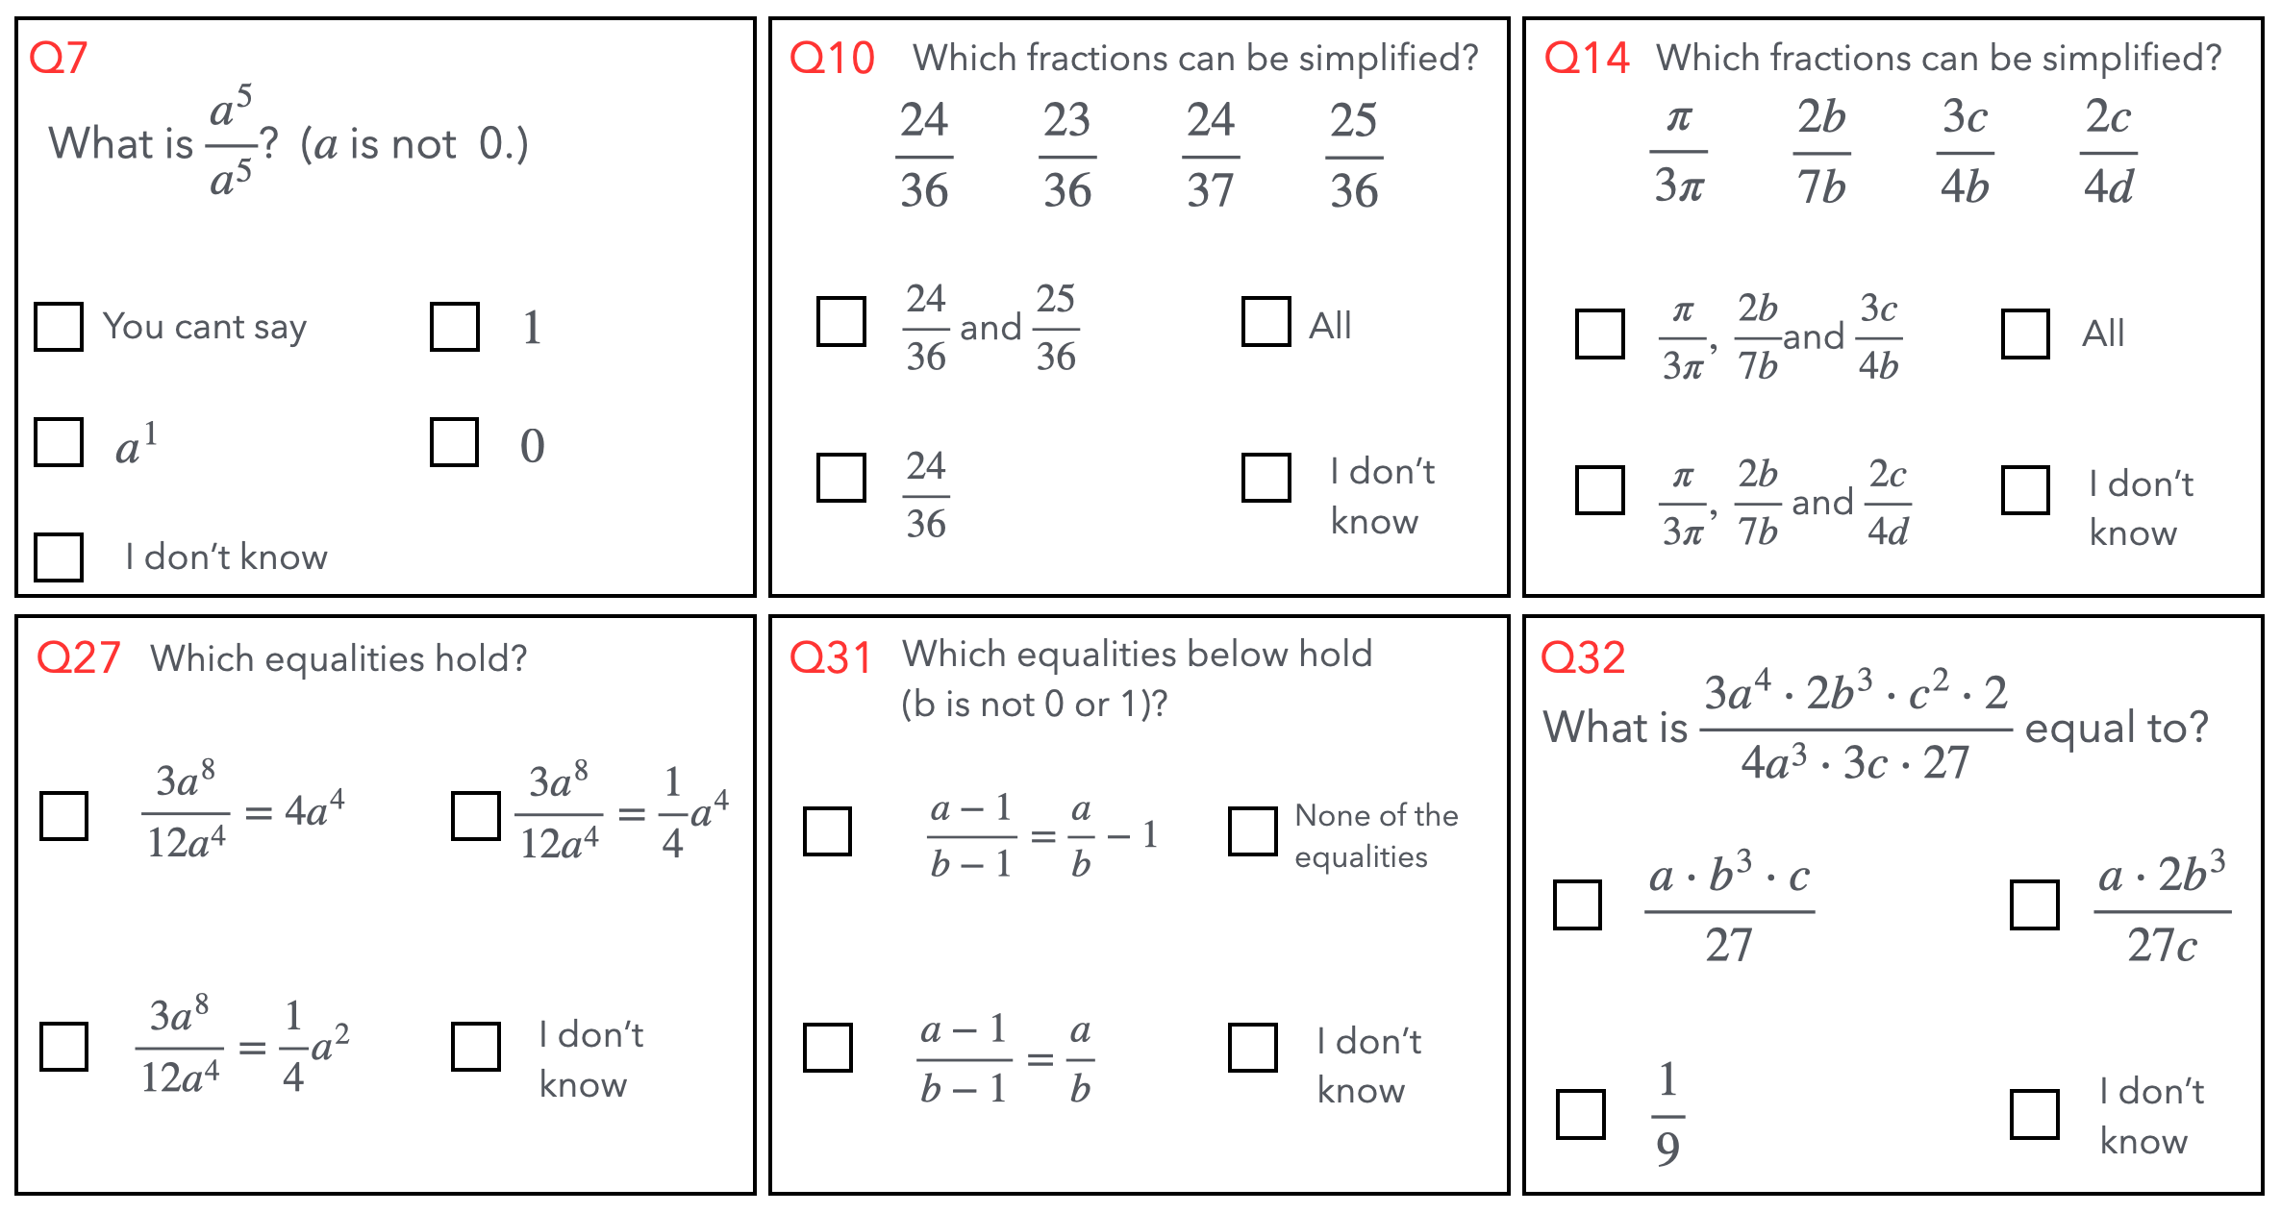
Figure 1. Five items that can be solved by repeated usage of $m/m=1$ and one (Q31) designed to capture erroneous usage of $m/m=1$. Items here are presented in a compact form, slightly different from the actual test layout.

Validation
We approach validation loosely based on Kane’s (2013) Interpretation/Use Argument (IUA) framework, which posits that validity is a property of an argument concerning the interpretation and use of test scores, and that validation is the scrutiny of this argument. Such an argument will use evidence that is pertinent to the specific interpretation and use of the test scores sought in each specific case.
Our test is intended to be used for evaluating the effectiveness of Algebra Monday in improving students’ algebra knowledge. The proposed interpretation of test scores is that they reflect relevant algebra knowledge. Validation therefore required evidence of the spread of item difficulty, sufficient item discrimination power, reliability, and potential presence of construct-irrelevant factors in the test administration. Additional information is included in Supplementary materials.
First, we needed to decide what to do about anomalous and missing data. We tested 471 students (May–June 2025). We excluded anomalies: 7 students spent <5 minutes (which we interpreted as not a serious attempt), and 79 had recorded times >60 minutes despite the 60-minute limit (sessions where students continued the test at a later date, which allows for discussing items between testing sessions and other algebra-irrelevant variables). For the remaining data, non-responses were scored 0. Because nearly all students finished within 50 of the 60 allotted minutes, even blanks at the end of the test are better interpreted as uncertainty than as a sign of time expiry. While we expected students to choose “I don’t know” for any question they did not have an answer for, many students left at least one missing answer. A possible explanation is that students may have skipped a question, intending to return or preferring not to choose "I don't know" simply because of the mouse maneuvering required. We therefore code missing answers as incorrect and note this as a minor limitation to monitor in the future.
Spread of difficulty and discrimination. For our test to capture a suitable range of student algebra ability, items should have a spread of difficulty which reflects the range of algebra knowledge of the students the test will be used with. Additionally, correct answers should be contingent on algebra ability, meaning that the items should have sufficient discriminating potential. We also wanted to later be able to examine the relative difficulty of the various items for standard students compared to Algebra Monday students, investigating the hypothesis that some item difficulties would change substantially when students have been instructed in algebraic structures. We therefore chose an item response theory (IRT) approach using the two-parameter logistic (2-PL) model, which estimates both item difficulty (β) (i.e., at what ability a student has a .5 probability of answering the item correctly) and item discrimination (α) (i.e., how well the item score distinguishes between students with lower and higher abilities). A 3-PL model which takes guessing into account was not appropriate because we had the “I don’t know option”, which changes the effect of guessing.
To choose which 2-PL IRT model to fit, we needed first to decide on the dimensionality of the data. While the test design included multiple categories of questions, these were meant to reflect teaching foci rather than ability subdomains. We therefore have no theoretical grounding either way for a uni- or multi-dimensional structure. We opted first to try a unidimensional model because of parsimony and ease of interpretation of the IRT statistics. We fit a one-factor Confirmatory Factor Analysis (CFA) using Weighted Least Squares Mean and Variance adjusted (WLSMV).
Given the near-identical content and format of Q04 and Q05, and a high tetrachoric correlation between them (r ≈ .900), we included a residual covariance between these two items in our model. The one-factor model showed a good fit and provided support for a one-dimensional model: scaled Comparative Fit Index (CFI) = .962 scaled Tucker-Lewis Index (TLI) = .959; Root Mean Square Error of Approximation (RMSEA) =.017 90% CI [0, .025]; Weighted Root Mean Square Residual =.983.
Based on the solid fit of the one-factor CFA, we then fit a unidimensional 2-PL IRT model. The evaluation of this model likewise fit well: the average correlation between residuals (denoted Q3, not to be confused with question Q03) was –.02, 99.5% of pairs |Q3| ≤ .20). Two pairs of items (Q04 and Q05, Q11 and Q17) showed notable local dependence (Q3 > .20) and may be revised in future forms of the test.
Discrimination parameters ranged from .192 to 1.82, with 24 of 34 items having discrimination above 0.64, which is considered moderate (Baker, 2001), and difficulties ranging from -1.54 to 3.56 logits, with a 6.51 logit outlier (Q27, see Figure 1). Most items thus successfully distinguish between students with lower versus higher abilities.
As the average difficulty of the items, we used the weighted mean of difficulties (𝛽-values), multiplying each item’s 𝛽-value by the discrimination α-value of each item, so that the items that discriminated best were given higher relative importance in the calculation. The weighted mean of 𝛽-values was .580, meaning that the test was towards the difficult side for this sample of students. The spread of item difficulties in comparison with the students’ abilities is shown in Figure 2.

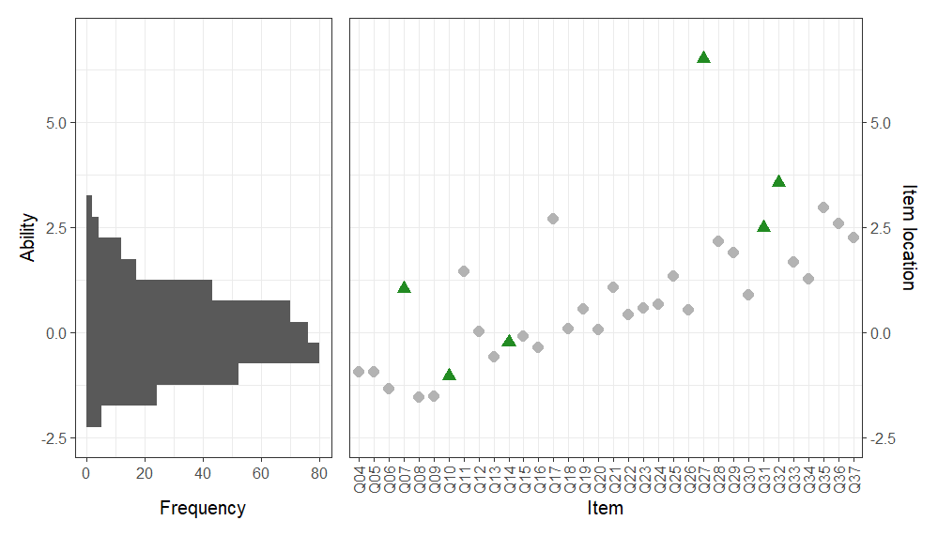
Figure 2. Respondent Algebra Ability and Item Location. Questions 7, 10, 14, 27, 31, and 32 (see Figure 1) are highlighted as triangles.
In relation to the categories and unified algebraic principles, such as $m/m = 1$, as illustrated in Figure 1, discrimination and difficulty of items in each category vary. For illustration, Table 2 presents the discrimination parameter α and item difficulty 𝛽 for the sample of items presented earlier in Figure 1. While the two questions that ask about which fractions can be simplified are easier than what the average student in this sample has equal odds of answering correctly (𝛽<0), the other four questions are more difficult. For example, question 7, asking students to simplify $a^{5}/a^{5}$ ($a$ is not 0) has difficulty 1.048, meaning roughly that for students to have equal odds of answering correctly and incorrectly, they need to be one standard deviation above the average ability in this group. Questions 27 and 32 are about the simplification of fractions that involve exponents. These questions have low discrimination power (below 0.65). Keeping in mind that the poor discrimination means that the estimate of difficulty is uncertain, they are the two most difficult items.

Item: | Q07 | Q10 | Q14 | Q27 | Q31 | Q32
α | 0.80 | 0.61 | 0.36 | 0.23 | 0.56 | 0.38
𝛽 | 1.05 | -1.05 | -0.23 | 6.51 | 2.48 | 3.56
Table 2. Item parameters for questions related to $\frac{m}{m}= 1$.
Reliability. Reliability here means the absence of random or algebra-irrelevant fluctuations in students’ scores and is a pre-condition for our interpretation of scores as reflecting algebra knowledge. Because we conducted an IRT analysis, we chose to use the expected a posteriori (EAP) marginal reliability, ρ, which is the average reliability across the range of different abilities, weighted by the proportion of students of each ability. It is considered good when it is above .800 and very good when it is above .900. The EAP marginal reliability ρ was .847, indicating good reliability, which in turn means that there is one clear signal, or construct, captured by the scores on this test.
Construct-irrelevant variance. Construct-irrelevant factors, in this case factors not related to algebra knowledge which systematically affect scores, can be detrimental to validity. Potential construct-irrelevant variance from timing and reading demands appears minimal. Under a 60-minute limit, 95% of students finished within 50 minutes. Regarding reading, some items necessarily used brief real-world scenarios to elicit algebraic modeling. While this introduces a possible reading-comprehension component, wording was kept straightforward, and automatic translation into multiple languages was available, reducing unintended language demands. Because the post-intervention cohort will have similar demographics and the same language supports, we tentatively believe that any remaining reading demand should be stable across groups and thus unlikely to affect estimates of intervention effects.

Discussion
We have presented an algebra test whose primary purpose is in the evaluation of the Algebra Monday intervention. The algebra test was designed with prior research on students' algebra difficulties in mind. The questions were chosen, whenever possible, among questions that had previously been studied in assessments of students' algebra skills, used on previously released Swedish National Tests, and, similarly to Blanton et al. (2019) aligned with the intervention that the test is meant to help evaluate. In this way, the test is simultaneously fit for the intended purpose and in parts similar to realistic assessments students may encounter during their schooling. A test designed to evaluate a different intervention should align with the narrow concerns of that intervention, as well as include items that more broadly capture the way the construct of interest is often represented.
The test showed good reliability with our sample of students, indicating that something has been measured. Because the items are designed as described above, that something is very likely algebra ability, as construed within the Algebra Monday intervention. A unidimensional structure was likewise observed, indicating that algebra knowledge, in this sample of students, is well-described as one thing, rather than multiple. The items are also spread out in difficulty and target the range of abilities in the sample of students, so it is suitable for the students we intend to use it with. For use with another group of students, reliability, dimensionality and appropriateness of difficulty should first be established for that group.
A limitation of our interpretation and use argument is that we have not yet measured students' response processes and, therefore, cannot say what knowledge or reasoning students used to solve test questions. While we designed the questions with the implicit belief that students would use knowledge of general algebraic structures to solve the structure questions, for example, it would be helpful in the future to assess whether some students may instead have used knowledge of exponent rules. Response processes should likewise be part of test validation for other algebra tests, because algebra problems often lend themselves to multiple solution methods.
A challenge for tests used in intervention studies is that they must be sensitive enough to capture the gains researchers hope to see from the intervention, yet not so difficult that control-group students become discouraged and stop trying. In this study, we cannot rule out that the overall difficulty of the test may have influenced some students’ effort on later items. Further research on students’ response processes could help clarify the extent to which test difficulty affects engagement and, in turn, score interpretation.
Additionally, because we believe that the algebra understanding and skills assessed by our test could be useful for learning various mathematics topics, such as coordinate geometry, the results should correlate with national test scores. They should, however, correlate less well with topics such as elementary probability or geometry, in which algebra plays a more minor role, at least in school mathematics. Future directions for validating our stated interpretation and use of this test could, therefore, include comparison with such external measures.
Some auxiliary findings also emerge from our analysis and may serve as inspiration for future research.
Questions which involve rational expressions with exponents appear especially difficult for our students, despite being eminently solvable by reasoning about exponents as repeated multiplication and the identity $m/m=1$. Also difficult were those questions that ask for scaling by fractions, where the correct answer is given as a fraction. Based on student notes in the testing platform, some students seem to have calculated a correct answer but then chosen an answer option that has an (incorrect) answer in decimal form. Additionally, it is noteworthy that so few students in our sample, in eighth grade, answered that $a^{5}/a^{5}=1$.
Despite designing our test based on three didactic approaches to teaching algebra, a one-factor model fit the data well. This is in contradiction to Zhang’s (2018) multi-factor approach to algebra. To our knowledge, Blanton et al. (2019) did not conduct a dimensionality analysis. Further research on dimensionality of algebra knowledge could explore dimensionality in different populations, with different conceptual frameworks, and based on exposures to different algebra curricula.

Conclusion
We have presented a 34-item algebra test that is closely aligned with the structural focus of Algebra Monday and validated its use as a group-level outcome measure for students in grade 8. The test shows good reliability, a unidimensional structure, and a reasonable spread of item difficulties, while potential construct-irrelevant influences from timing, reading load, and anomalous test-taking behaviors appear limited. At the same time, our analyses highlight areas of algebra that are particularly challenging for students, such as rational expressions involving exponents and scaling by fractions.
As Algebra Monday is implemented over a longer period, this test and subsequent IRT analyses will allow us to examine whether instruction with a strong emphasis on algebraic structure changes the relative difficulty of structurally related items, and how change in this type of algebra knowledge relates to performance on broader national assessments. Researchers or educators who wish to use this test should be mindful that dimensionality and difficulty levels may differ based on students’ prior algebra experience. More generally, we hope this study contributes to wider discussion about how researcher-designed tests for intervention studies are constructed and how the interpretation and use of such instruments can be systematically validated.

Acknowledgement
This paper is part of grants 2024-00048 at Skolforskningsinstutet and MAW 2024.0112 at Marcus and Amalia Wallenbergs stiftelse.

References
Baker, F. B. (2001). The basics of item response theory (2nd ed). ERIC Clearinghouse on Assessment and Evaluation.
Blanton, M., Stephens, A., Knuth, E., Gardiner, A. M., Isler, I., & Kim, J. S. (2015). The development of children's algebraic thinking: The impact of a comprehensive early algebra intervention in third grade. Journal for Research in Mathematics Education, 46(1), 39–87. https://doi.org/10.5951/jresematheduc.46.1.0039
Blanton, M., Stroud, R., Stephens, A., Gardiner, A. M., Stylianou, D. A., Knuth, E., Isler-Baykal, I., & Strachota, S. (2019). Does early algebra matter? The effectiveness of an early algebra intervention in grades 3 to 5. American Educational Research Journal, 56(5), 1930–1972. https://doi.org/10.3102/0002831219832301
Hackenberg, A. J., & Sevinc, S. (2022). Middle school students’ construction of reciprocal reasoning with unknowns. The Journal of Mathematical Behavior, 65, 100929. https://doi.org/10.1016/j.jmathb.2021.100929
Helenius, O., & Ahl, L. M. (2024). A framework for analyzing long-term early algebra progression in textbook series. In T. Evans, O. Marmur, J. Hunter, G. Leach, & J. Jhagroo (Eds.), Proceedings of the 47th Conference of the International Group for the Psychology of Mathematics Education, Vol. 3 (pp. 9–16). IGPME.
Hilton, A., Hilton, G., Dole, S., & Goos, M. (2013). Development and application of a two-tier diagnostic instrument to assess middle-years students' proportional reasoning. Mathematics Education Research Journal, 25(4), 523–545. https://doi.org/10.1007/s13394-013-0083-6
Kane, M. (2013). The Argument-Based Approach to Validation. School Psychology Review, 42(4), 448–457. https://doi.org/10.1080/02796015.2013.12087465
Kaput, J. J. (2008). What is algebra? What is algebraic reasoning? In J. J. Kaput, D. W. Carraher, & M. L. Blanton (Eds.), Algebra in the early grades (pp. 5–18). Lawrence Erlbaum Associate.
Kieran, C. (2004). Algebraic thinking in the early grades: What is it? The Mathematics Educator, 8(1), 139–151.
Kieran, C. (2018a). Seeking, using, and expressing structure in numbers and numerical operations: A fundamental path to developing early algebraic thinking. In C. Kieran (Ed.), Teaching and Learning Algebraic Thinking with 5- to 12-Year-Olds (pp. 79–105). Springer International Publishing. https://doi.org/10.1007/978-3-319-68351-5_4
Kieran, C. (Ed.). (2018b). Teaching and Learning Algebraic Thinking with 5- to 12-Year-Olds. Springer International Publishing. https://doi.org/10.1007/978-3-319-68351-5
Niss, M., & Jankvist, U. T. (2013). 13 Spørgsmål fra Professoren (detektionstest 3). Materiale udleveret til matematikvejlederuddannelsen [13 Questions from the Professor (detection test 3). Material handed out at the maths counsellor programme].
Opsal, H., & Topphol, A. K. (2023). The problematic equal sign. NOMAD Nordic Studies in Mathematics Education, 28(1–2). https://doi.org/10.7146/nomad.v28i1-2.149263
Roesken-Winter, B., Stahnke, R., Prediger, S., & Gasteiger, H. (2021). Towards a research base for implementation strategies addressing mathematics teachers and facilitators. ZDM – Mathematics Education, 53(6), 1193–1206. https://doi.org/10.1007/s11858-021-01220-x
Stephens, A., Stroud, R., Strachota, S., Stylianou, D., Blanton, M., Knuth, E., & Gardiner, A. (2021). What early algebra knowledge persists 1 year after an elementary grades intervention? Journal for Research in Mathematics Education, 52(3), 332–348. https://doi.org/10.5951/jresematheduc-2020-0304
Zhang, Z. (2018). Designing cognitively diagnostic assessment for algebraic content knowledge and thinking skills. International Education Studies, 11(2), 106–117. https://doi.org/10.5539/ies.v11n2p106

By email to ola.helenius@ncm.gu.se

