Mapping shadow education in mathematics
in an upper secondary school in Sweden

Robert Gunnarsson & Linda Maria Sjögren

School of Education and Communication, Jönköping University, Sweden
Despite what many mathematics teachers may hope, students in secondary school do not seek help in their mathematics studies because they are curious about mathematics, but rather because they want to pass their tests. This is one of the conclusions of our survey of 229 students. Our study shed light on contemporary shadow education by exploring the types of support students use outside school and what motivates them to seek support in their mathematical studies. We find that regarding digital support types, students choose support where there is little or no interaction. Moreover, we find that almost half of the students claim to have used paid private tutoring, indicating a growing presence of shadow education in Sweden.

Introduction
Mathematics is a challenging subject for many secondary school students all around the world, including in Sweden. In this context, private supplementary tutoring, often described as shadow education, has become increasingly important (Bray, 2009; Mikhaylova, 2022; Smyth, 2009). Actually, in many studies of private supplementary tutoring, support specifically in the mathematics subject is often requested (e.g., Ireson & Rushforth, 2009; Zhang & Liu, 2022; Özdere, 2021).
The term shadow education covers supplementary educational support provided outside the formal school system, including private tutoring, online platforms (such as instructional videos or interactive exercises), and support offered by non-profit organizations or homework help-centers (Bray, 2009; Kobakhidze & Suter, 2020). While shadow education has a long history in many countries, particularly in East Asia (Bray, 1999), it is a relatively recent phenomenon in the Nordic countries, including Sweden (Christensen & Zhang, 2021; Hallsén & Karlsson, 2019). The use of shadow education has implications for educational equity, since access to and the quality of supplementary support often vary according to socioeconomic resources (Entrich & Lauterbach, 2019; Ku et al., 2024). This raises questions about how similar patterns might appear in Sweden, where both free and paid support are available.
Until now, there have been only a few studies on Swedish students’ use of support in mathematics, with research focusing either on social, institutional, and interactional aspects of private tutoring (Hallsén & Karlsson, 2019; Svahn & Melander Bowden, 2019) or on digital tutoring and tutor-student interaction (Hrastinski et al., 2021). Hence, so far, no study has been devoted to how students in Swedish upper secondary schools use existing support structures. Therefore, this present study, which is part of a larger research project on shadow education in Sweden, aims to explore how students in an upper secondary school consult different types of support. We map the different types of support students use within the subject of mathematics, and describe what motivates them to seek such support outside of school.

Previous research
The technological advancement has changed the landscape of private supplementary tutoring in recent years. Although support through one-to-one private tutoring seems to be the most frequent form of support, new forms and types of support are emerging and are increasingly asked for (Karakus et al., 2024). Particularly, the COVID-19 pandemic seems to have accelerated the search for new digital tools to support student learning (see, e.g., Akin, 2022). However, this does not come without complications. Melander Bowden and Svahn (2020) point out that digital support is formed by the limitations and affordances of the online platform it is distributed by. In addition, other studies have pointed out challenges related to communication with online tutoring compared to non-digital tutoring (Hrastinski et al., 2021; Zang et al., 2023).
Students’ motives for going beyond the support their school offers for learning mathematics have been described for more than two decades (see, e.g., Bray, 1999). The motives include the desire to achieve higher grades, boost self-confidence, or compensate for (what the student perceives as) inadequate teaching (Hajar, 2018; Wigfield & Eccles, 2000). Actually, students with clear goals and lower confidence in their skills are more willing to seek support outside the school (Wigfield & Eccles, 2000). Furthermore, the initiative to seek support outside school may not only improve academic performance but also positively influence students’ motivation and overall satisfaction with school and life (Guill et al., 2020).
However, improving mathematical confidence or general mathematics skills is not the only reason for students to seek support. Studies also indicate that students often seek support to meet performance requirements or pass exams rather than to deepen their understanding of the subject (e.g., Prendergast et al., 2022). Parents often play an active role in this process, especially in contexts where such support is viewed as a strategy to secure educational success and social status (Entrich & Lauterbach, 2019; Ireson & Rushforth, 2009; Mikkelsen & Gravesen, 2021).

Aim and research questions
There is a wide range of types of support that students could use outside of the offer from the school system. There is also a variety of motives for using shadow education identified in previous research. Therefore, this study aims to explore the shadow education used for mathematics education by students in a Swedish upper secondary school. We do this by answering the following research questions: (RQ1) What types of support are students using? and (RQ2) What are the students’ motives for using such out-of-school support resources? We primarily answer these questions quantitatively.

Method
To address the research questions, a digital survey focusing on various aspects of shadow education was constructed. The development of the survey was carried out through repeated discussions and collaborative review of the content. A pilot was conducted in an upper secondary school class (grade 12) at a different school from the one included in this study. Based on the feedback from the pilot and from subsequent focus group interviews, the survey was revised to improve clarity and structure, including providing additional examples for all categories and offering a QR code so that students could complete the survey on their mobile phones rather than via a computer link. In the final design, the survey included multiple types of questions: Likert-scale questions, multiple-choice questions, and open questions, allowing students to elaborate on their experiences in their own words. Open questions such as “What other types of support do you use?” and “Other motives to use support?” were included to ensure that significant alternative answers were not missed.

Participants and data collection
The survey was distributed to students in one (a single) upper secondary school in Sweden, out of which 245 students opened and started answering the questions. Not all students completed the survey. The number of answers was slightly different for the different questions. At most 229 students’ answers could be analyzed for a set of questions. For some sets of questions, it was lower. The participants were not selected based on any prior criteria; all students in the participating classes were invited to take part. The students were either currently studying mathematics or had studied mathematics as part of their program curriculum.
All participating students were enrolled in one of four university preparatory programs. The students in the Natural Science Program (16% of the participants) attended grade 3, while those in the Social Science Program (25%), the Economic Science Program (27%), and the Arts Program (27%) attended grade 2; 5% of the participants did not specify which program they were enrolled in. Of the participants, 76% identified themselves as female, 21% as male, and 3% did not disclose their gender. The survey was conducted over two weeks in late May 2025, after students had completed both the national tests and other final assessments in mathematics.

Data handling and analysis
The data were anonymised directly at the point of collection, as students did not provide any names or personally identifying information in the survey. The survey described in this report is part of a larger study of students’ use of shadow education that has been approved by the Swedish Ethical Review Authority. Hence, all collected data are stored securely and in accordance with ethical guidelines and relevant data protection guidelines.
The authors analysed the data separately and in joint sessions. In the current study, only quantitative data were included. Other questions included background questions (these are accounted for above), and questions with Likert-scale answers (e.g., “To what extent have you benefited from support?”), which are not accounted for in this report. A comparative analysis was conducted to examine patterns in students’ use of digital and non-digital support. The survey questions asked for students’ use of several different types of support, both types that could be counted as shadow education, and types that could be considered outside of shadow education (like support from school and from parents). In some cases, we have included those for comparison. Moreover, to make the data more convenient to handle, we divided the different types into different categories, as described below.

Results
In this section, we present answers to the most relevant questions from the survey, which together provide answers to our research questions.

What types of support are used?
Questions about the types of support students use were divided into several categories, as each type was asked for separately. It could be, e.g., “Do you use this digital/non-digital support in mathematics outside of lesson-time? Private tutoring [Yes/No]”. Digital and non-digital support types were asked for in separate clusters.

Digital support types
Figure 1(a) shows a summary of the use of various digital support types. We observe that platforms, being either general video-on-demand platforms like YouTube and TikTok, or specific mathematics platforms (with a mix of text and video), like matteboken.se or eddler.se, are commonly used. The content of the videos and on the mathematics platforms is fixed, and communication is directed from the platform to the student. This is a type of support with one-way communication.

Figure 1. Use of digital support in shadow education, by type (a) and by category (b)
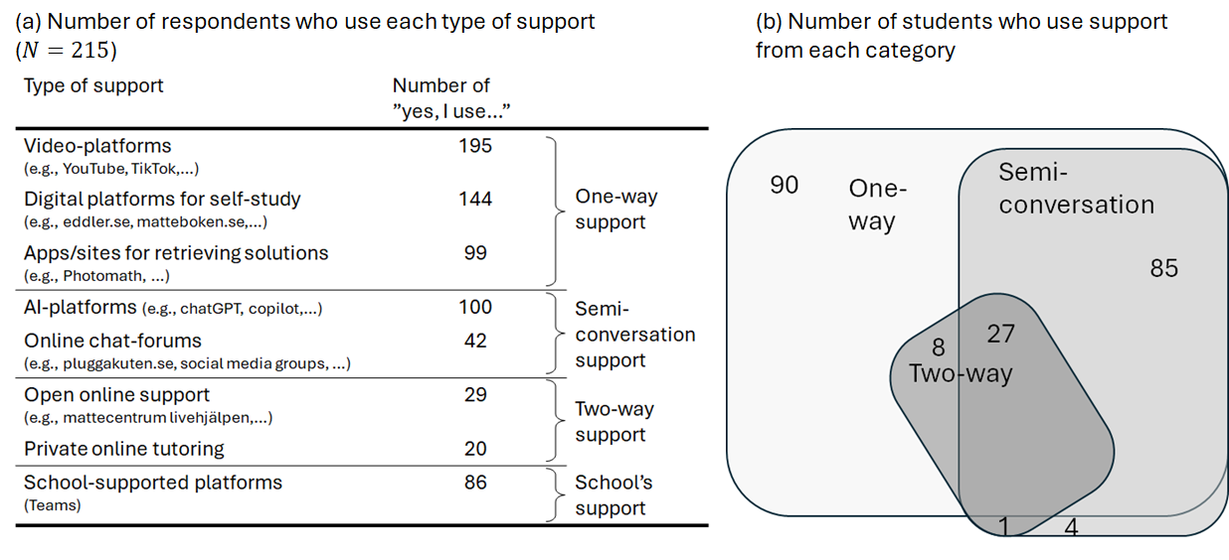

Also frequently used are forums and platforms where the students can have either a semi-conversation with a chatbot (like, e.g., AI text generators) or an asynchronous chat with a real person. A much smaller number of students are using support that involves an actual, real-time two-way conversation with another (living) person. As a comparison, the school offered a chat function in their digital learning management system (they used Microsoft Teams), and the number of students using this type of support is included at the bottom of Figure 1(a). The number of students using that type of non-shadow education exceeded the number using support by real-time two-way conversations, but was smaller than the number of students seeking support by shadow education tools of the type that did not involve a “live” person-to-person discussion. However, students could use many types of support in parallel. To get an idea of the use of multiple types of support in shadow education, we defined three main categories of support: one-way support, semi-conversation support, and real-time two-way support. In the category one-way support, we include video platforms (like YouTube and TikTok), digital platforms for self-studies (two common platforms in Sweden are eddler.se and matematikboken.se), and apps/websites for retrieving mathematical solutions (the one most frequently mentioned by the students was Photomath, but there are many more on the market, like, e.g., Mathway, Quanda). In the category semi-conversation support, which comprises semi-two-way support types, we include AI tools and online chat forums. In the category of two-way support, we include such types of shadow education that involve real-time person-to-person conversations.
Figure 1(b) shows the number of respondents in each of these categories. Almost all respondents use some kind of one-way support, half of the respondents also use semi-conversation support functions, and a small percentage of the respondents use two-way support functions–most of them as a complement to both one-way support and semi-conversation support. No student used any kind of two-way support only, without using one-way or semi-conversational support. In addition, we can compare the number of students who use some kind of semi-conversational support (117 respondents marked at least one of these support types, see “semi-conversation support” in Figure 1b) to the number of students who used the school’s support function (86 respondents, see bottom row in Figure 1a). These two alternatives are comparable since they both rely on asynchronous, chat-like functions. Hence, it is safe to say that outside of mathematics lesson hours, more students are using online semi-conversational chat-support functions (including AI) to communicate with an unknown responder than students who turn to their teachers with similar chat tools.
We did not observe a major difference between females and males regarding the use of different categories of support (at most a difference of a couple of percentage points). However, there could be a difference regarding which study program they attended. Students in the Natural Science Program and those in the Social Science Program utilized two-way support functions to a greater extent (20% and 31%, respectively) than students in the Arts Program and the Economic Science Program (6% and 10%, respectively).

Non-digital support types
Naturally, a student could be asking a friend or a parent for advice and support in their mathematics studies. Indeed, we see that a majority say that they use family and/or friends as support in their mathematics studies (189 of 229 students). To separate this type of support from the organized forms of shadow education, we summarize these under the name Informal support (free), since we assume that the friends or the family do not get paid. Although this does not traditionally count as shadow education, we include it here for comparison.
However, there are types of non-digital shadow education support that are either free or for payment and given by organizations or private persons. For lack of better words, we call these categories Non-profit support (free) and Private support (paid), respectively. In the category of Non-profit support (free), we find group tutoring (in Swedish: “räknestugor”) from organisations like, e.g., “Mattecentrum” and other non-profit organizations. In the category of Private support (paid), we include all types of paid private tutoring with real-time physical meetings with a person (which could be hired privately, or through a professional study support service).
Figure 2 shows a summary of the number of students that has marked that they use any of the types of support that we divide into these three categories: Informal support (free), Private support (paid), and Non-profit support (free). In total, 189 students (i.e., $81+50+12+46$, in Figure 2) marked that they used family and/or friends, i.e., Informal support (free), 65 students marked that they used organizations, Non-profit support (free), and almost half of the students ($105=50+46+4+5$, in the figure) marked that they used alternatives that involved some kind of paid study support, Private support (paid).

Figure 2. Number of students who are using other (non-digital) types of support, sorted in three categories.
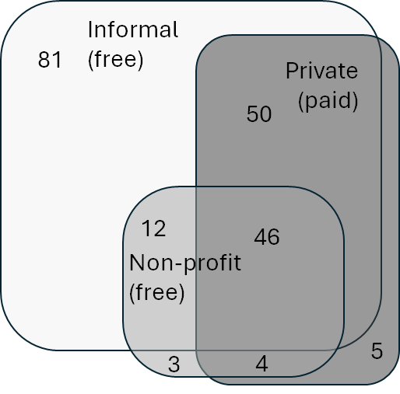
Note: Total number of respondents for this question: $N=229$

We are aware that some types of support are quite similar. For instance, the (non-digital) support type “Organized (free)” has many similarities to Open online support (from Figure 1a). One can note that the Swedish organization ”Mattecentrum” acts in both categories, with both digital and non-digital mathematics support.

Why are students seeking support?
Students’ reasons for seeking support are primarily to manage the mathematics course, see Figure 3 for a summary of the different answers. The reasons “as preparation for national/other tests” and “to get help with specific tasks” were each marked by more than two-thirds of the students. Almost half of the students (117 of 219) marked “to be able to follow the teaching in school”. Only a small number of students marked reasons indicating other self-improvements within the subject of mathematics.
The answers from female students and male students are almost identical (details not shown here), with only small differences between the groups. The only major difference is that a larger proportion of male students marked that they seek support to access greater mathematical challenge compared to their female peers (15% of the male students compared to 8% of the female students), although the number of students that marked this alternative was small (21 in total, see Figure 3). However, we observe that the female students, on average, selected slightly more alternatives (mean value of 4,1 “reasons” for females compared to 3,7 “reasons” for male students).

Figure 3. Students’ reasons for seeking support in mathematics (multiple answers possible) ($N=219$)
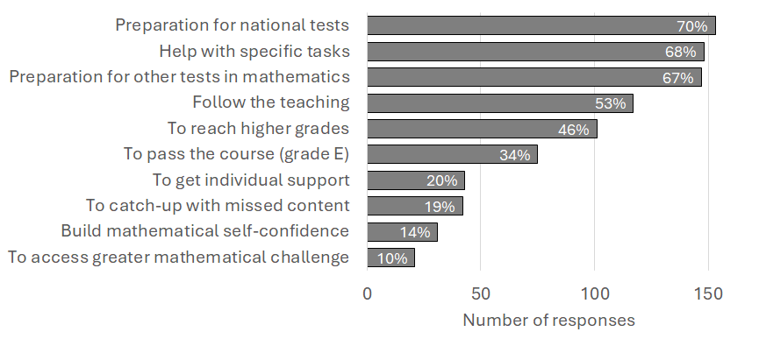
Hence, the main reason for students to seek support in mathematics of the types mentioned above seems to be to prepare for tests, either national tests or other (i.e., teacher-made) tests. Also, the alternatives “to get help with specific tasks” and “to be able to follow the course” were quite frequently marked. The commonality between these options is that they all reflect some type of external factors. The least marked reasons instead reflect internal factors, such as improving their own mathematical skills. We observe that even though it is the least marked reason, “to access greater mathematical challenge” is marked by almost 10% of all students (21 answers out of 219).

Discussion
Although there was a limited number of participants in this study (N=229), we can make some statements based on our quantitative observations.
First, we observe that the largest group providing support is friends and parents, the category we call Informal (free) support (Figure 2). This informal support does not fall under the definition of shadow education (Bray, 2009), but it remains relevant due to the data. We believe we can safely assume the student already has a relationship with friends and parents. Hence, a “safe-haven” for asking questions appears to be important for these students, similar to what was indicated by Melander Bowden & Svahn (2020). They describe that face-to-face support relies on a supportive relationship where the student does not feel judged. Therefore, we believe this is what we see too in our data.
However, we find it interesting that almost half of the students (105 out of 229 in Figure 2) are using paid private tutoring. These findings align with a growing interest in the phenomenon of private paid tutoring in Sweden. Previous research has shown a recent expansion of the organized sector of shadow education in the Swedish context, particularly in paid forms of support (Christensen & Zhang, 2021; Hallsén & Karlsson, 2019). Hence, almost half of the students are paying for face-to-face support, although it is not within the “safe-haven” of family or friends.
Second, we observe that students seem to prefer support types that can be categorized as “one-way”, and a much smaller number of students use real-time “two-way” conversation support with an actual person (Figure 1). The use of one-way, typically video-based support types has been described before (Akin, 2022; Ireson & Rushforth, 2009; Mikkelsen & Gravesen, 2021; Entrich & Lauterbach, 2019). We are aware that the study by Karakus et al. (2024) suggests that asynchronous video tutoring (which we include in the category of “one-way”) is the only type of support that shows statistically significant improvement in students’ mathematical performance. However, other studies point out that online support presents different challenges in the communication between student and tutor as the absence of gestures, facial expressions, and tone of voice can make interaction more difficult (Hrastinski et al., 2021; Zang et al., 2023). Based on our data presented here, we can not say anything about the objective effectiveness of the support, but only comment on the prevalence of students using digital one-way support. We find that only a small number of students report engaging in synchronous (two-way) support (Figure 1b). It seems they instead prefer asynchronous forms that do not require real-time interaction. Without further and more detailed data, we can not fully corroborate Wigfield and Eccles’ (2000) observation that students with low academic confidence tend to avoid more interactive support.
Third, we observe that the majority of students seek tutoring or support for their studies to manage the course, pass the test(s), or get answers to specific questions. Almost two-thirds of the students mark that this is the reason for seeking support (Figure 3). This is a much larger number than the ones seeking mathematics support because they are genuinely interested in the subject (the two alternatives in Figure 3 with the lowest number of respondents). We could only speculate on the reason for this.
The results of this study can, similar to Entrich & Lauterbach (2019) and Ku et al. (2024), be interpreted in the light of research indicating that shadow education may reinforce socioeconomic differences in education. In Sweden, where students can access both free and paid support, it remains an open question how these choices will influence equity in the future. This study represents the initial phase of a larger research project about shadow education; future work will build on the insights gained by exploring qualitative dimensions of students’ learning experiences when using out-of-school support.

References

Akin, A. (2022). The effectiveness of web-based mathematics instruction (WBMI) on K-16 students’ mathematics learning: A meta-analytic research. Education and Information Technologies, 27(6), 8015–8040. https://doi.org/10.1007/s10639-022-10931-x
Bray, M. (1999). The shadow education system: Private tutoring and its implications for planners. United Nations Educational, Scientific and Cultural Organization (UNESCO).
Bray, M. (2009). Confronting the shadow education system: What government policies for what private tutoring? UNESCO. International Institute for Educational Planning (IIEP). Paris, France (2009).
Christensen, S., & Zhang, W. (2021). Shadow Education in the Nordic Countries: An Emerging Phenomenon in Comparative Perspective. ECNU Review of Education, 4(3), 431–441. https://doi.org/10.1177/20965311211037925
Entrich, S. R., & Lauterbach, W. (2019). Shadow Education in Germany: Compensatory or Status Attainment Strategy? Findings from the German LifE Study. International Journal for Research on Extended Education, 7(2), 143–159.
Guill, K., Ömeroğulları, M., & Köller, O. (2022). Intensity and content of private tutoring lessons during German secondary schooling: effects on students’ grades and test achievement. European Journal of Psychology of Education, 37(4), 1093–1114. https://doi.org/10.1007/s10212-021-00581-x
Hajar, A. (2018). Exploring Year 6 pupils’ perceptions of private tutoring: evidence from three mainstream schools in England. Oxford Review of Education, 44(4), 514–531. https://doi.org/10.1080/03054985.2018.1430563
Hallsén, S., & Karlsson, M. (2019). Teacher or friend? – consumer narratives on private supplementary tutoring in Sweden as policy enactment. Journal of Education Policy, 34(5), 631–646. https://doi.org/10.1080/02680939.2018.1458995
Hrastinski, S., Stenbom, S., Benjaminsson, S., & Jansson, M. (2021). Identifying and exploring the effects of different types of tutor questions in individual online synchronous tutoring in mathematics. Interactive Learning Environments, 29(3), 510–522.
https://doi.org/10.1080/10494820.2019.1583674
Ireson, J., & Rushforth, K. (2009). Private tutoring at transition points in the English education system: its nature, extent and purpose. Research Papers in Education, 26(1), 1–19. https://doi.org/10.1080/02671520903191170
Karakus, M., Tlessov, A., Hajar, A., & Courtney, M. (2024). Illuminating the shadows: the role of private supplementary tutoring on student math performance in PISA 2022. Large-scale Assessment in Education, 12, 42 (2024). https://doi.org/10.1186/s40536-024-00228-5
Kobakhidze, M. N., & Suter, L. (2020). The Global Diversity of Shadow Education. European Journal of Education. https://doi.org/10.1111/ejed.12411
Ku, I., Lee, H., & Kim, J. E. (2024). Does shadow education contribute to inequality? Asia Pacific Journal of Education, 44(4), 773–791. https://doi.org/10.1080/02188791.2022.2114424
Melander Bowden, H., & Svahn, J. (2020). Collaborative work on an online platform in video-mediated homework support. Social Interaction. Video-Based Studies of Human Sociality, 3. https://doi.org/10.7146/si.v3i3.122600
Mikhaylova, T. (2022). Shifting shadows: Private tutoring and the formation of education in imperial, Soviet and post-Soviet Russia. [doctoral thesis] Uppsala University.
Mikkelsen, S. H., & Gravesen, D. T. (2021). Shadow Education in Denmark: In the Light of the Danish History of Pedagogy and the Skepticism toward Competition. ECNU Review of Education, 4(3), 546–565. https://doi.org/https://doi.org/10.1177/2096531120983335
Prendergast, M., O’Meara, N., Duffy, L., & O’Rourke, I. (2022). Delving into the shadow: Mathematics teachers’ perspectives on the impact of private supplementary tutoring in Ireland. Asian Journal for Mathematics Education,1(3), 323–337. https://doi.org/10.1177/27527263221129637
Smyth, E. (2009). Buying Your Way into College? Private Tuition and the Transition to Higher Education in Ireland. Oxford Review of Education, 35(1), 1–22.
Svahn, J. & Melander Bowden, H. (2019). Interactional and epistemic challenges in students’ help-seeking in sessions of mathematical homework support: Presenting the problem. Classroom Discourse, 12(3), 193–213. https://doi.org/10.1080/19463014.2019.1686998
Wigfield, A., & Eccles, J. S. (2000). Expectancy–Value Theory of Achievement Motivation. Contemporary educational psychology, 25(1), 68–81. https://doi.org/https://doi.org/10.1006/ceps.1999.1015
Zhang, E., & Liu, Y. (2022). Effects of private tutoring intervention on students’ academic achievement: A systematic review based on a three-level meta-analysis model and robust variance estimation method. International Journal of Educational Research, 112, Article 101949. https://doi.org/10.1016/j.ijer.2022.101949
Zhang, L., Pan, M., Yu, S., Chen, L., & Zhang, J. (2023). Evaluation of a student-centered online one-to-one tutoring system. Interactive Learning Environments, 31(7), 4251–4269. https://doi.org/10.1080/10494820.2021.1958234
Özdere, M. (2021). The demand for private tutoring in Turkey: An analysis of private tutoring participation and spending. Journal of Education and Learning, 10(3), 96–111. https://doi.org/10.5539/jel.v10n3p96

