Sarah’s construction of a method for division with multi-digit dividends and single-digit divisors

Björn Palmberg^{1,2}, Johan Sidenvall^{1,3}, Anna Ida Säfström^{1,2}, & Johan Lithner^{1,2}

¹Umeå Mathematics Education Research Centre, Umeå University, Sweden ²Department of Science and Mathematics Education, Umeå University, Sweden

³Municipality of Hudiksvall, Hudiksvall, Sweden
Division is regarded as the most difficult of the four basic operations for students to learn. Yet, there is little research on how teaching can support students learning of methods for multi-digit division. Supporting students’ own construction of methods, rather than letting students imitate given methods, has been shown to result in more sustainable learning for other mathematical topics. However, designing teaching that is contingent to students’ own construction requires knowledge of students’ construction processes for the method in question. In this case study, we provide a detailed example of such a process regarding a method for multi-digit division. The results show that students can construct increasingly sophisticated methods for multi-digit division based on additive partitions of the dividend into multiples of the divisor.

Division is complex to teach and learn (Hickendorff et al., 2019; Neuman, 1999). Although studies show that different types of teaching lead to different student learning of division methods (Anghileri et al., 2002; van Putten et al., 2005), still too little is known about how multi-digit division teaching should be designed to best promote learning for all students (Hickendorff et al., 2019). Suggestions point to the importance of students building their knowledge from informal methods and inventing their own methods, and that students’ development of division methods is influenced by students’ multiplicative and relational thinking (Ambrose et al., 2003; Anghileri et al., 2002; Schulz, 2024). In Swedish textbooks, multi-digit division is usually explicitly taught in Grades 4–6, restricted to single-digit divisors and up to four-digit dividends. The most common method taught is short division, first introduced for divisions for which no sub-divisions result in any remainders, and then for divisions with increasing number of sub-remainders and increasing number of digits in the dividend.
For other mathematical topics, studies have demonstrated learning advantages of letting students develop and construct solution methods, rather that imitating solution methods when solving tasks (Jonsson et al., 2014; Lester & Cai, 2016). However, designing teaching that promotes students’ own construction requires knowledge of students’ construction processes for the method in question and how such processes can be promoted. There are pre- and post-test accounts of changes in students’ division methods (e.g., van Putten et al., 2005; Schulz & Leuders, 2018), but, to our knowledge, no accounts of the actual learning process during training. In this case study we therefore investigate one Grade 4 student’s process of constructing a method for division of multi-digit dividends and one-digit divisors in a teaching design aimed at promoting students’ independent construction of such a method.

Difficulties with methods for division
Compared to the other operations, division is conceptually harder since it embraces both quotative and partitive situations (Sellers, 2010). Understanding multi-digit division also requires sufficient knowledge and skill in addition and subtraction, as well as fluency in the 1–10 multiplication tables (Hickendorff et al., 2019). Division algorithms, such as short division, are digit-based methods as they allow one to handle each digit separately, ignoring the value of the numbers the digits represent, often leading to mistakes (Ambrose et al., 2003; Hickendorff et al., 2019). Besides general difficulties with algorithms, such as knowing when to apply them (Verschaffel et al., 2007), a specific difficulty of division algorithms is that they go from left to right, while the algorithms for addition, subtraction, and multiplication commonly go from right to left (Hickendorff et al., 2019).
In number-based methods, both the numerical value and the position are respected. Therefore, they require students to have a sufficient conceptual understanding of the place value system (Hickendorff et al., 2019). One example of such a method is Split and add (Schulz, 2024), where the dividend is additively partitioned into numbers for which the quotient with the divisor is known to the student and the sub-quotients are added to obtain the result, for example 126/3 = 120/3 + 6/3 = 40 + 2 = 42. When students are allowed to develop number-based multi-digit division methods, they usually start from repeated adding or subtracting for quotative problems and equal sharing of small parts of the dividend using visual representations for partitive problems (Verschaffel et al., 2007). Such methods become cumbersome and error-prone as dividends grow larger (Neuman, 1999; Anghileri et al., 2002). Over time, students may progress to using larger multiples, or ‘chunks’ of the divisor in successively more efficient ways, as for Split and add (Hickendorff et al., 2019; Verschaffel et al., 2007). However, students’ own development of number-based methods can also sometimes result in ‘buggy procedures’ (Hickendorff et al., 2019), indicating that design of teaching that supports successful and accurate development of division methods may require careful consideration.

Teaching designs for development of methods
A large number of studies have suggested that students are given greater opportunity to develop mathematical understanding when they construct their own solution methods, than when they are given methods to imitate (Boaler, 1998, 2014; Schoenfeld, 1985, 2018). That students better remember methods that they have constructed themselves has been verified in several recent studies using control groups (e.g. Jonsson et al., 2014; Norqvist et al., 2025), but these studies are limited to short interventions and methods for single tasks. For the learning of division, van Putten et al. (2005) studied how Grade 4 students developed long division for multi-digit divisors over five months. The students were supported by teaching based on students’ informal methods and own construction of subsequently more advanced methods. Schulz and Leuders (2018), in a multifaceted intervention with some explicit instruction of informal methods and a focus on development of methods, studied students’ progression to more sophisticated methods for solving divisions. Both of these studies leverage pre- and post-tests to infer probable development during instruction, but they do not actually study what happens during training. To our knowledge, there is yet few studies describing how students, without at least in part explicit instruction, may construct general methods over sequences of tasks, and no study describing how this can be done for division with single-digit divisors and multi-digit dividends.

Aim and Research Question
As described above, several previous studies suggest that there are learning advantages to constructing a solution method, even though this is difficult for students. Yet, it is not known how teaching can facilitate this in the case of division with multi-digit dividends and single-digit divisors. A first step would be to investigate if, and if so how, students can construct a reasonably efficient general method for multi-digit division (e.g., one that does not rely on equal sharing of unit objects) without explicit instruction (e.g., without the teacher demonstrating methods). This study aims to contribute to such investigations by considering one student’s work during a teaching experiment with constructive task and teacher support design. The research question is: How may a Grade 4 student’s process of constructing a method for division with multi-digit dividends and one-digit divisors manifest in a constructive task and teacher support design without explicit instruction?

Method
This study is a sub-study within a larger design research project aiming to develop and test constructive teaching design for learning central mathematical methods. The data was collected from three lessons and two post-tests during an experiment aiming to test and compare teaching designs for learning a general method for division with multi-digit dividends and one-digit divisors. Before the experiment, the students had been taught and practiced on inverse multiplication tasks, that is, division tasks that can be solved by inversing the multiplication facts included in the 1–10 multiplication tables.

The teaching design
The teaching design was based on a sequence of tasks hypothesised to support students’ construction of a general method by successively increasing the difficulty of the tasks. Since it is not possible to predetermine the methods students will develop in constructive designs, we weighed in four factors in the task sequence: 1) context: the presence of context could support students’ initial attempts at constructing a method. The first five tasks in the sequence were therefore set in a common context of Max’s class setting up a school play (Table 1). 2) Size of dividend: larger dividends could be harder to think about and represent, making tasks with two-digit dividend easier than tasks with three-digit dividend. 3) Size of divisor: students in Grade 4 were assumed to be more fluent in the 2–5 multiplication tables than the 6–9 multiplication tables, making tasks with the former as divisors easier. 4) Whether the sub-divisions produced one or two remainders. Though the fourth factor was based on the standard algorithm, we expected that this property would translate to the methods the students developed, as this property is based on the relationship between the dividend and the divisor. We expected the five context tasks to take up most of the lesson time but also prepared worksheets (WS) with non-context tasks (Table 1). On the post-tests, tasks 1, 3 and 5 were context-tasks, and task 2 and 4 non-context tasks.

Task type | Context task (CT) | WS
Two-digit dividend, one remainder | CT1. 78 of the students go by bus to the theatre where they practise. It takes 3 buses to take all students. How many students are in each bus, if there are equally many in each bus? | WS1
Three-digit dividend, one remainder: all tens | CT2. For all 615 students to see the play they are divided equally to three shows. How many students are there in each show? | WS2
Three-digit dividend, one remainder: all hundreds | CT3. The class has baked cookies to sell at the shows. Max suggests that they sell equally many cookies at each show. They have baked 156 cookies. How many cookies should they sell at each show? | WS2
Three-digit dividend, one remainder: part of tens | No CT. | WS3
Three-digit dividend, one remainder: part of hundreds | CT4. The class has sold tickets to the three shows for 756 SEK. If they have sold equally many tickets to each show, how much money did they get for each show? | WS3
Three-digit dividend, two remainders | CT5. Another school has heard about the play and also want to see it. At that school, there are 765 students. Max’s class gives another three shows. If the students are divided equally, how many students are coming to each show? | WS4
Table 1. Task types for context tasks and worksheets included in the task sequence
In addition to the tasks, students were encouraged to use concrete base-10 materials and ask the teacher for help whenever they needed. The teacher was instructed to help students by supporting their creative mathematical reasoning (Säfström et al., 2025). As part of the teacher support, supporting tasks could be given to the context tasks, asking the same question but for a simpler dividend: 60, 600, 150 or 750, and following this up by asking if the answer to the simpler task could be used for solving the original task. Lesson 1 and 3, as well as the two post-tests, each ended with an explanation task that asked the student to describe their solution to one of the division tasks they had worked with earlier that session.

Data and analysis
To answer the research question, the work of one student, Sarah (a pseudonym), was selected as a case. Before the teaching sequence, Sarah could solve simple division tasks but had not worked with tasks where the dividend was not found in the multiplication table and the dividend’s digits were not evenly divisible by the divisor. The data consisted of Sarah’s written work during lessons and post-tests, and audio recordings of her interactions with the teacher. We selected this case since it illustrates how a student can develop a successively more general method for division with multi-digit dividends and single-digit divisors.
To answer our research question, we adopted qualitative level-raising analysis (Simon, 2019), meaning that each step of the analysis used the result from the previous step as data, forming a recursive process that established a chain of inferences that stayed close to the data in each step. The idea with level-raising analysis is to avoid inferential leaps from data to conclusions and make the overarching conclusion less demanding to make and easier to trace back to the data. It consisted of three levels, starting with analysis of Sarah’s work on each task, then analysing it in relation to her work on previous tasks and finally analysing her process over the whole task sequence. The analysis was first conducted separately by the first and second author, who then discussed their analysis and reached a common, refined analysis, incorporating details identified by each researcher. At Level 1, Sarah’s written work on the task was described with as much detail as possible. If Sarah had explained her reasoning for the division task as her response to an explanation task, this was also included as data. If Sarah and the teacher had interacted about the division task, the transcription of the interaction was partitioned into segments where the teacher supported Sarah with the same thing in similar ways, the teacher support in each segment was described, and the teacher support regarding the task was summarised based on the descriptions of the segments. The results of the Level 1 analysis were therefore twofold: a characterisation of the method Sarah used for the task (similarly to characterisations by Schulz (2024) and others) and a characterisation of any support the teacher provided to her. At Level 2, the results from Level 1 for the current and all previous tasks were used to identify which (correct and incorrect) steps in the solution for the task Sarah constructed herself, and which steps she already knew or was given by the teacher. At Level 3, the results of Level 2 for all the tasks Sarah had worked with was used to construct a narrative of when which steps of a general method for division with multi-digit dividends and single-digit divisors were constructed by her. The results consist of the narrative that was the result of the Level 3 analysis, which naturally includes results from the analysis on Level 1–2.

Results
Through working with eleven tasks during three lessons, Sarah developed the Split and add method (Schulz, 2018) for three-digit dividends and one-digit divisors, first with concrete materials and then in writing. She interacted with the teacher regarding three tasks, restricted to the teacher asking questions about Sarah’s reasoning, supporting interpretation of the context and a few questions asking for evaluation of what she had done. Her effort and success in applying this method depended on whether an additive partitioning was directly “visible” in the dividend or not, that is, whether the partitioning could be made in between place values, either as one part with the hundreds and another with the tens and ones or as one part with ones and the other with the hundreds and tens. She was able to use her method successfully for dividends with a visible bipartition, for example 615 = 600 + 15, or a partly hidden tripartition, for example 492 = 400 + 80 + 12, where 400 is a visible part whereas 80 and 12 are hidden parts, and extended the method to hidden bi- or tripartition on Post-test 1 (Table 2).

Lesson 1: Constructing the visible bipartition method
Sarah first engaged with CT1 (78/3). In her attempt to solve the task she drew buses on a paper and then shared concrete base-10 materials between the buses until there was nothing left. As seen in Figure 1, she drew three buses and first put twenty students in each bus, sharing out 60. She then added another five to each bus, sharing out 15. However, the materials she had added up to 75, not 78. Therefore, she believed she was finished. At this point, the teacher asked Sarah to explain her solution, and the teacher highlighted that Sarah seemed to be missing some pieces to represent all 78 students: “Are you not missing some ones? Did you have 78 from the beginning? I think you are missing ones; they are over there, on the table”. When the teacher left, Sarah wrote “20 + 5 +” but then crossed over the plus sign. This indicates that Sarah realized that the teacher indicated that something more should be added to each of the buses, but she did not finish the task and instead moved on to the next task.
 | Lesson 1 |  |  | Lesson 2 |  | Lesson 3 |  |  |  |  | Post-test 1 |  |  |  |  | Post- test 2
Task  Type | $$\frac{78}{3}$$ | $$\frac{615}{3}$$ | $$\frac{156}{3}$$ | $$\frac{756}{3}$$ | $$\frac{765}{3}$$ | $$\frac{156}{3}$$ | $$\frac{492}{4}$$ | $$\frac{651}{3}$$ | $$\frac{876}{4}$$ | $$\frac{165}{3}$$ | $$\frac{24}{2}$$ | $$\frac{48}{4}$$ | $$\frac{126}{2}$$ | $$\frac{565}{5}$$ | $$\frac{732}{6}$$ | $$\frac{22}{2}$$ | $$\frac{39}{3}$$ | $$\frac{142}{2}$$ | $$\frac{575}{5}$$ | $$\frac{882}{9}$$
Visible bipartition |  | R | S |  |  | R |  |  |  |  | R | R | R |  |  | R | R | R
Partly hidden tripartition |  |  |  |  |  |  | R | R | R |  |  |  |  | R |  |  |  |  | R
Hidden tripartition |  |  |  | W | W |  |  |  |  |  |  |  |  |  | R
Hidden bipartition | W |  |  |  |  |  |  |  |  | W |  |  |  |  |  |  |  |  |  | NA
Note. R = right answer, S = started but got stuck, W = wrong answer, NA = not attempted.
Table 2. Overview of Sarah’s methods and success on tasks she worked with
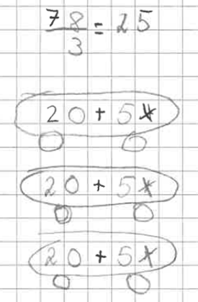
Figure 1. Sarah’s solution of 78 divided by 3
Next, Sarah worked on CT2 (615/3). For this task, she did not use concrete base-10 materials but partitioned the dividend in hundreds and the rest (a visible bipartition of 615) and recorded the sub-divisions in writing (Figure 2A). She then added the quotients, obtaining the correct answer. In Figure 2B we see her own explanation of how she solved the task.

A | 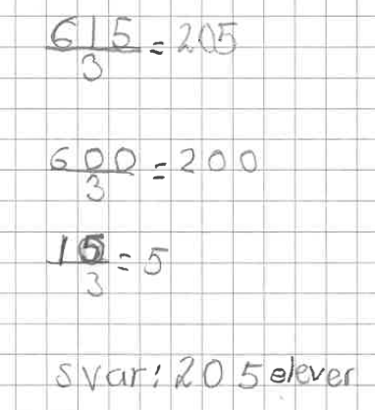  English translation. “Answer: 205 pupils” | B | 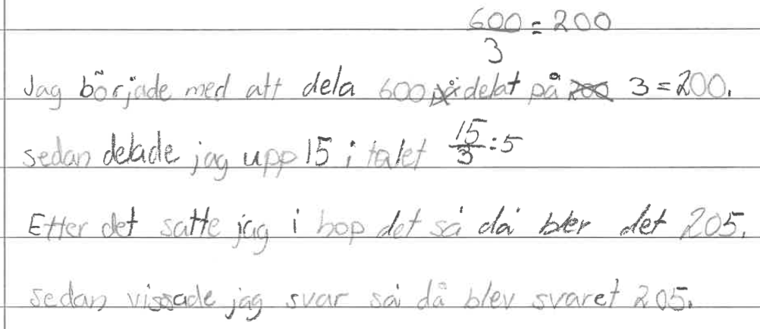  English translation. “I started by dividing 600 divided by 3 = 200. Then I divided 15 in the number 15/3 = 5. After that I put it together, so it became 205. Then I showed the answer, so it became the answer 205.”
Figure 2. Sarah’s solution and explanation of 615 divided by 3
In her attempt to solve CT3 (156/3) —also a task that can be solved using a visible bipartition—Sarah continued to use the solution method from CT2. Starting with division of the hundreds she wrote 100/3, but got stuck, seemingly because 100 is not divisible by three. When Sarah asked the teacher for help, she was encouraged to look at the previous task and see if her solution there could help her come up with an idea. Since Sarah had started with dividing the hundreds in the task before, she had a hard time to come up with something new and when she thereafter tried to use manipulatives, she chose a square representing one hundred, five rods representing tens, and six small cubes, which did not help her overcome her difficulty. The lesson ended without Sarah solving the task.

Lesson 2: Beginning to construct the hidden tripartition method
During Lesson 2 Sarah worked with CT4 (756/3) and CT5 (765/3), both requiring hidden partitions. She seemed to realize that if she chose to start with the hundreds, she needed to first find a part of the hundreds (600) that is divisible by three. She worked with these two tasks the whole lesson. At the end of the lesson, she wanted to explain what she had done, and it was evident that Sarah understood that there was one hundred left to divide by three and that she had tried to use a similar approach to the hundred seeing it as ten tens (i.e., to divide as many tens as possible). “They are 200 [600 divided by 3], and then I took those /…/ then I took the hundred and made it into ten [i.e., ten tens] and divided that. /…/ Then there was one piece left. Then I took from there [the tens and ones]” However, as can be seen in Figure 3, Sarah struggled with keeping track of her reasoning, i.e., what she had divided and what remained to be divided of the hundreds, tens and ones. Although she had correctly determined the sub-divisions of a hidden tripartition of 756—600/3, 9/3 (i.e., nine tens divided by three), and 66/3—she has also made many other attempts, and when trying to find the quotient she failed to identify which attempts were successful. When the teacher, after listening to Sarah’s explanation leading up to the suggested answer 250, asked her to verify that this was correct, Sarah did not manage to do this.
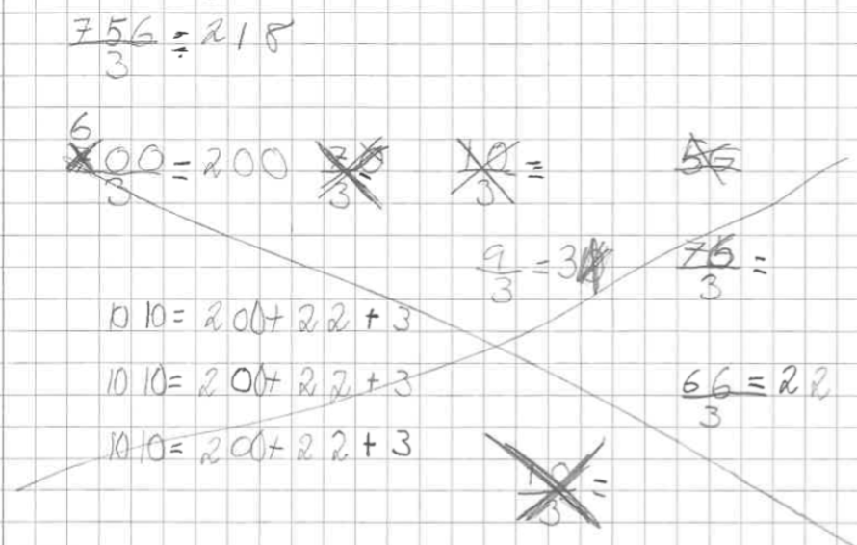
Figure 3. Sarah’s solution of 756/3

Lesson 3: Constructing the partly hidden tripartition method
In the third lesson Sarah was first given the supporting task for CT3 (150/3) and then CT3 (156/3) again. Sarah solved the supporting task by realizing that 50+50+50=150 and then used this fact to solve CT3 by a visible bipartition: 150 + 6. Sarah was then given Worksheet 3 on which she successfully solved three tasks (492/4, 651/3, 876/4) by partly hidden tripartition in all hundreds, a part of the tens divisible by the divisor and the rest of the tens together with the ones (Figure 4A). However, Sarah was still unable to solve the fourth task on the worksheet, which had no visible part divisible by the divisor (see Figure 4B).
A | 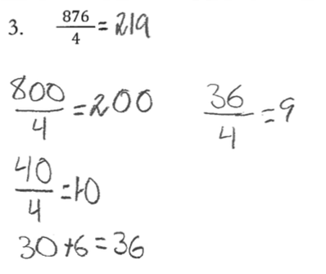 | B | 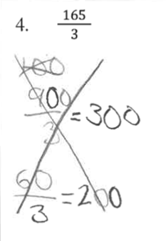
Figure 4. Sarah’s written work for 876/4 and 165/3

Post-tests 1 and 2: Extending to a hidden partition method
On the first post-test, a week after the training, Sarah successfully used her visible bipartition and partly hidden tripartition methods to solve 126/2 and 565/5, respectively. She also managed to solve a task with no visible parts (732/6). Her notes of how she solved this task are blurry. She has written the correct answer (122) and several other numbers that do not clearly indicate a solution method. In the explanation task, however, she described her method as taking 600/6 = 100, 30/6 = 5 and that she intended to calculate 42/6, indicating that her solution entails identifying at least three hidden parts of the dividend, but Sarah did not explain how or if she handled the last 60 of the dividend.
On the second post-test, five weeks after training, Sarah still successfully used visible partition and partly hidden tripartition (142/2, 575/5), but she was unable to solve the task requiring hidden bipartition: 882/9. This may indicate that the method she used on Post-test 1 was partly hidden tripartition.

In sum, we answer our research question in the following way: In this context, a Grade 4 student can construct Split and add for division with multidigit dividends and one digit divisors through a process entailing the construction of three key ideas in the following order: 1) partitioning dividends consisting wholly of visible, known divisible parts (e.g., for divisor 3, partitioning 615 into 600 and 15) and adding the results of sub-quotients, 2) after partitioning a dividend with one visible, known divisible part and a not-known part (e.g., for divisor 4, partitioning 492 into 400 and 92), partitioning the not-known part into two known parts (80 and 12), and 3) partitioning a dividend with no visible, known divisible parts into known parts (for divisor 6, possibly partitioning 732 into, 600, 30, 42 and 60). Sarah’s wrong answers to CT1, 4 and 5 indicates that for her, it was not possible to construct Idea 2 and 3 without first constructing Idea 1.

Discussion
The study shows that it is possible for students to learn methods for solving multi-digit division with single-digit divisors without being presented with the standard algorithm (as is common in Swedish textbooks and traditional instruction), explicit instruction with discussions of number-based methods or much individual support. It furthermore shows that progress in development of a method can be made over a relatively short period of time, similarly to Schulz and Leuders (2018), complementing studies with a longer time frame (e.g., van Putten et al., 2005). Foremost, it shows the actual process that students can experience from task to task over a series of lessons. These findings give insights into the feasibility of allowing students to construct their own solution methods and indicates how tasks may promote or not promote such development. The study furthermore exemplifies how students’ learning processes can be studied over lessons through Simon’s (2019) notion of level-raising analysis.
It has been shown that knowledge of the other operations and their relations can be associated with greater progress in development of general methods for division (Schulz, 2024). Sarah’s quick transition from use of concrete materials to written methods, and a lack of examples of where the context supported her, may indicate that her previous mathematical knowledge was strong. For the design of the tasks, we conjectured that dividends with fewer digits would be easier. However, for Sarah, hidden bipartitions of two-digit dividends (as in 78/3) seem to be more difficult than hidden tripartitions of three-digit dividends. This may be because the partitioning of the hundreds only, which you can always start with for hidden tripartitions, may be easier to invent than the partitioning of the hundreds and the tens together, which is required in hidden bipartitions. For the standard short division method, one remainder is likely to be equally difficult no matter where it appears, but for the Split and add method, it can be a significant difference if a partly hidden tripartition starts with the visible or the hidden part. This suggests that students’ success in developing their own methods may depend on how tasks are sequenced in terms of which parts of the dividend are visible or hidden.
Some limitations of the study should be noted. The nature of our research question and the detailed analysis of one student afford insights into one student’s learning process. However, this focus and scope naturally limit generalizability, both regarding conclusions about whether the process studied is common or idiosyncratic and how the teaching design, as compared to other teaching designs, influences the student’s development of a method. Future studies could leverage the affordances of our approach of a detailed study of the student’s process over lessons and overcome limitations by, for example, including analysis of more students with different characteristics and compare students’ development of a method for solving division problems under different conditions.

Authors’ contributions Conceptualization and procedure: all authors. Data collection: J.S. Development of analysis method: A.I.S with support from B.P. and J.S. Analysis: B.P. and J.S. First drafts: B.P., J.S., and A.I.S. Substantial revisions: B.P. and J.S. with contributions from A.I.S. All authors critically reviewed the manuscript for important intellectual content. Funding Swedish Institute for Educational Research 2022-00072.

References
Anghileri, J., Beishuizen, M., & Van Putten, K. (2002). From informal strategies to structured procedures: Mind the gap!. Educational Studies in Mathematics, 49(2), 149-170. https://doi.org/10.1023/A:1016273328213
Ambrose, R., Baek, J.-M., & Carpenter, T. P. (2003). Children’s invention of multidigit multiplication and division algorithms. In A. J. Baroody & A. Dowker (Eds.), The development of arithmetic concepts and skills (pp. 305–336). Erlbaum.
Boaler, J. (1998). Open and closed mathematics: student experiences and understandings. Journal for Research in Mathematics Education, 29(1), 41-62. https://doi.org/c745vv
Boaler, J. (2014). The road to reasoning. In K. Brodie (Ed.), Teaching mathematical reasoning in secondary school classrooms (p. v-vii): Springer Nature. https://doi.org/c745vv
Hickendorff, M., Torbeyns, J., & Verschaffel, L. (2019). Multi-digit addition, subtraction, multiplication, and division strategies. In A. Fritz, V.G. Haase, P. Räsänen (Eds.), International handbook of mathematical learning difficulties: From the laboratory to the classroom (pp. 543–560). Springer International Publishing. https://doi.org/p4fx
Jonsson, B., Norqvist, M., Liljekvist, Y., & Lithner, J. (2014). Learning mathematics through algorithmic and creative reasoning. Journal of Mathematical Behavior, 36, 20–32. https://doi.org/10.1016/j. jmathb.2014.08.003
Lester Jr., F. K., & Cai, J. (2016). Can mathematical problem solving be taught? Preliminary answers from 30 years of research. In Felmer, P., Pehkonen, E., Kilpatrick, J. (Eds.), Posing and solving mathematical problems: Advances and new perspectives (pp. 117–136). Springer. https://doi.org/10.1007/978-3-319-28023-3_8
Neuman, D. (1999). Early learning and awareness of division: A phenomenographic approach. Educational Studies in Mathematics, 40(2), 101-128. https://doi.org/d7brs8
Norqvist, M., Jonsson, B., & Lithner, J. (2025). Shifts in student attention on algorithmic and creative practice tasks. Educational Studies in Mathematics, 118(3), 409–428. https://doi.org/gsmkgb
Schoenfeld, A. H. (1985). Mathematical problem solving. Academic Press.
Schoenfeld, A. H. (2018). Video analyses for research and professional development: The teaching for robust understanding (TRU) framework. ZDM Mathematics Education, 50(3), 491-506. https://doi.org/10.1007/s11858-017-0908-y
Schulz, A. (2018). Relational reasoning about numbers and operations–foundation for calculation strategy use in multi-digit multiplication and division. Mathematical Thinking and Learning, 20(2), 108–141. https://doi.org/10.1080/10986065.2018.1442641
Schulz, A. (2024). How Do Multiplicative and Relational Thinking Contribute to Multidigit Division? Journal für Mathematik-Didaktik, 45(2), 21. https://doi.org/p4fw
Schulz, A., & Leuders, T. (2018). Learning trajectories towards strategy proficiency in multi-digit division – A latent transition analysis of strategy and error profiles. Learning and Individual Differences, 66, 54–69. https://doi.org/10.1016/j.lindif.2018.04.014
Sellers, P. A. (2010). The trouble with long division. Teaching Children Mathematics, 16(9), 516–520. http://dx.doi.org/10.5951/TCM.16.9.0516
Simon, M. A. (2019). Analyzing qualitative data in mathematics education. In K. R. Leatham (Ed.), Designing, conducting, and publishing quality research in mathematics education (pp. 111–122). Springer. https://doi.org/10.1007/978-3-030-23505-5_8
Säfström, A. I., Palmberg, B., Anderson, C., Lithner, J., Boström, E., Granberg, C., Palm, T., & Sidenvall, J. (2025). Developing a formative assessment framework for supporting students’ reasoning during problem solving [Manuscript submitted for publication]. Department of Science and Mathematics Education, Umeå University.
van Putten, C. M., van den Brom-Snijders, P. A., & Beishuizen, M. (2005). Progressive mathematization of long division strategies in Dutch primary schools. Journal for Research in Mathematics Education, 36(1), 44–73. https://doi.org/10.2307/30034920
Verschaffel, L., Greer, B., & De Corte, E. (2007). Whole number concepts and operations. In F. K. Lester Jr. (Ed.), Second handbook of research on mathematics teaching and learning (pp. 557–628). Information Age Publishing.

