Promoting student engagement with feedback through formative assessment in mathematics

Catarina Andersson^{1,2}, Mikael Winberg^{1,3}, Björn Palmberg^{1,2}
& Torulf Palm^{1,2}

¹Department of Science and Mathematics Education, Umeå University, Sweden; ²Umeå Mathematics Education Research Centre (UMERC);
³Umeå Science and Technology Education Research (UmSTER)
For teacher feedback to be most beneficial for student learning, students would need to proactively seek and actively engage with it. Embedding feedback within a formative assessment practice has been proposed as a means to support such student engagement. In this study, we investigate a mathematics teacher’s development of a formative assessment practice and the associated changes in students’ engagement with feedback during individual task solving. Inductive thematic coding of classroom audio-recordings was used to identify characteristics of changes in student-teacher interactions, and Orthogonal Projections to Latent Structures Discriminant Analysis was employed to examine multivariate differences between lessons. Results indicate that changes in the teacher’s practice were accompanied by increased student engagement with feedback.

Background
Several meta-analyses and systematic reviews have demonstrated that teacher feedback can yield substantial positive effects on student outcomes, including achievement both in general (Wisniewski et al., 2020) and specifically in mathematics (Palm et al., 2017; Van der Kleij & Lipnevich, 2021). However, effect sizes vary substantially, and Van der Kleij and Lipnevich (2021, p. 373) concluded that: “the relation between feedback and learning is still poorly understood, and past research sheds limited light on the specific mechanisms of feedback and its links to meaningful educational outcomes”. One proposed partial explanation for this knowledge gap is the limited body of research examining how students interpret and respond to feedback (Winstone et al., 2017).
In general, students’ intentional, proactive and constructive participation in learning situations has been shown to support positive outcomes such as enhanced learning (Patall, 2024). In line with these general results, scholars have suggested that to realize the full benefits of teacher feedback, students need to proactively seek and actively engage with the feedback, rather than remaining passive recipients (Winstone et al., 2017). In the context of mathematics task solving, such engagement involves articulating difficulties and specific support needs rather than leaving interpretation to the teacher, and constructing mathematical reasoning grounded in intrinsic properties of the task rather than relying on superficial recall of procedures (Lithner, 2008).
It may be noted that engagement is not a fixed student attribute; rather it is shaped by contextual factors such as teaching. Yet, practical guidance on how to support students in shifting from passive to active engagement with feedback remains limited (Winstone et al., 2017). Most empirical research on the topic concerns higher education students and focuses on engagement with feedback for the purpose of resubmission of assignments (Winstone et al., 2017). Research on younger students’ engagement with teacher feedback during task solving—particularly in the mathematics classroom—is scarce. Bishop (2021) and Ing et al. (2015) are two exceptions. Bishop (2021) found that in whole-class instruction, “the intellectual work requested by the teacher was related to the level of intellectual work students provided, acting as an upper bound on students’ mathematical activity” (p. 466). Analysing whole-class and small-group settings, Ing et al. (2015) found that teacher elicitation of student thinking was positively related to students’ production of fully articulated mathematical explanations. However, neither study examined changes in teacher practice or corresponding shifts in student engagement with feedback.
Embedding feedback in a formative assessment (FA) practice has been suggested as a means to support students’ active engagement with the feedback (Palmberg et al., 2024). FA is an instructional practice in which teachers and/or students elicit evidence of learning needs and adapt feedback, learning activities, or learning strategies accordingly (Black & Wiliam, 2009). Meta analyses and systematic reviews across subjects and grade levels have consistently shown that such practices can substantially improve achievement, regardless of whether teachers or students act as the primary agents (e.g., Yao et al., 2024), including in mathematics (Palm et al., 2017). However, despite widespread promotion of FA in many countries, its high-quality implementation is uncommon in educational practice, including in Sweden (Andersson et al., 2017). Implementing FA in mathematics education entails specific challenges and changes that are not easy to accomplish. Changes may, for example, involve moving away from intuitive responses such as re-teaching or guiding students toward specific solutions, towards more responsive practices that take up and build on students’ ideas (e.g. Jacobs et al., 2022). Such practices hold strong potential but are complex to enact, often requiring sustained professional support to develop both teachers’ beliefs and their instructional repertoires.
Palmberg et al. (2024) documented increased student engagement in mathematics classrooms where FA was successfully implemented. However, the most common mathematics learning format internationally involves students working individually on tasks (Hiebert et al., 2003), including in Sweden (Boesen et al., 2014). Palmberg et al. (2024) did not focus on such settings, but the present study does. Here, we focus on FA practices where the teacher, as the primary agent, (1) elicits evidence of student knowledge and skills, (2) interprets this evidence to infer students’ learning needs, and (3) provides feedback tailored to those needs. Such FA practices are intricate and challenging (Black & Wiliam, 2009), with weaknesses at any stage risk reducing the overall quality and effectiveness of FA (Palm et al., 2023).

Research questions
In the present study, we investigate an elementary school teacher’s development of a FA practice in mathematics and the accompanying changes in students’ engagement with feedback during teacher-student interactions when students sought help during individual task solving. We address the following research questions:
- What changes occur in the teacher’s FA practice?
- What accompanying changes occur in students’ engagement with the feedback process?

Methods

Procedure and data collection
Together with all mathematics teachers in two schools, the teacher participating in this study attended a three-year long professional development program (PDP) in FA. The PDP addressed a broad range of FA aspects, including the teacher as a proactive agent who elicits evidence of student learning and adapts feedback or subsequent learning activities to identified learning needs. It also addressed the teachers’ role in supporting students to take a more active role in core FA processes through peer assessment and peer feedback, as well as self-assessment followed by learner-initiated actions to reach learning goals
During the second year the participating teacher volunteered for an additional individualized PDP focusing specifically on providing feedback to students when they seek help during individual task solving. We investigated changes in the teacher’s practice and students’ engagement with the teacher’s feedback before, during, and after this individualised support. Data were collected through audio recordings of teacher–student interactions made by the teacher, and these interactions were inductively coded. The coded data were then analysed statistically to identify differences in both teacher and student actions from the beginning to the end of the individualised support period.

Participants
An experienced and highly engaged mathematics teacher, Lisa (pseudonym), volunteered to participate in the study. Twenty of her 25 students (11 female, 9 male; ages 11–12) also consented to participate, with informed consent provided by their legal guardians. The students represented diverse socio-economic and cultural backgrounds.

Professional development
Research has identified key features of effective professional development (PD), including access to instructional resources, opportunities for practice, interactive feedback, time for implementation, and external expertise (Heitink et al., 2016), along with the value of a formative orientation to the PD (Andersson & Palm, 2018). The individualised PD support in this study was designed to align with these principles.
The teacher made classroom audio recordings of her interactions with individual students when they sought help with task solving in March, May, October, and November 2022, and in January and March 2023, typically two recordings per month. During the individualised PD meetings, initiated in October 2022, the last author provided both oral and written feedback to Lisa based on these recordings. Over the weeks that followed, Lisa used the feedback to further develop her FA practices at her own discretion. New recordings were then collected, followed by a new cycle of feedback. This iterative process continued for 6 months, with meetings held in October and November 2022, and February, March, and April 2023. Each meeting—including discussions of the researcher’s feedback and Lisa’s feedback to her students—lasted between 60 and 80 minutes.
The feedback provided during the meetings included successful examples of implementations of Lisa’s FA practices, and guidance on how to further strengthen her FA. The support focused on the elicitation, interpretation, and feedback processes. It included strategies for eliciting information about students’ thinking through questioning, encouraging students to articulate their reasoning, and helping them proactively share information about their understanding. Question types that could be used by both the teacher and students to make students’ thinking explicit were discussed. Suggestions regarding feedback practices were also provided, emphasising feedback that is tailored to identified learning needs, supports students’ construction of mathematical reasoning, and recognises progress while attributing success to internal, unstable, and controllable causes. Challenges in implementing desired FA practices were also examined, along with possible underlying causes, in order to identify feasible approaches for improvement. These approaches included introducing changes incrementally, starting with students more receptive to these changes, creating a supportive environment for students to practice new behaviours, and providing feedback that reinforces the benefits of, for example, sharing their thought processes. An example of feedback to the teacher was: “Is it clear [to students] how you are actually helping them thanks to what they told you they could and could not do? Can they see the positive consequences of you being better informed?”

Data Analysis
A comprehensive analysis of Lisa’s FA practices was conducted through inductive thematic coding (Braun & Clarke, 2006) of classroom recordings collected between March 2022 and March 2023. This period encompassed time both before, during, and after Lisa began receiving individual feedback. In total, 351 minutes of audio recordings were encoded directly in MaxQDA (i.e., without prior transcription). Inductive codes were generated through close examination of the data capturing recurring actions, or patterns in the lessons. Through repeated reading and comparison, these initial codes were refined, grouped, and differentiated until they represented meaningful themes grounded in the data. Code development was carried out collaboratively by five researchers, resulting in high agreement regarding how each code should be applied.
The coding framework captured both concrete aspects of the feedback practices (e.g., telling a student an answer was incorrect) and broader qualities of practice, such as whether the teacher had elicited sufficient information about students’ underlying learning needs, as determined by the coder. Codes were also developed to describe students’ engagement with the feedback process. In total, 61 codes were constructed. Using MaxQDA, segments of the audio recordings associated with each code were marked, and the time allocated to each form of FA practice and each type of student engagement was summarized for each lesson. Any uncertainties regarding code application were discussed collectively until consensus was reached, after which the final coding was conducted by one researcher to ensure consistency.
To examine multivariate differences between lessons conducted before and after Lisa began to receive individual feedback (RQ1), Orthogonal Projections to Latent Structures Discriminant Analysis (OPLS-DA; Bylesjö et al., 2006) was employed. OPLS-DA was selected due to the p >> n structure of the dataset, with 61 coded variables (p = 61) derived from only 12 lessons (n = 12), a context in which approaches commonly used in educational research—even more advanced regression-based models—typically require more observations than predictors and rely on assumptions rarely met by coded qualitative data. Because OPLS-DA is designed for high-dimensional, collinear data (Trygg & Wold, 2002; Bylesjö et al., 2006), it allows patterns of co-occurring behaviours to be modelled by separating predictive from non-predictive variance and estimating the contribution of individual codes.
Preliminary analyses suggested no immediate effect of the researcher feedback, so lessons from spring 2023 were compared with lessons from 2022 to maximise contrast.

Results
The OPLS-DA analysis of qualitative codes revealed significant changes in Lisa’s FA practices (RQ1) and in student engagement with the feedback process (RQ2) following the period of individualized professional development (Figure 1 and Table 1). The OPLS model demonstrated strong discriminatory power and produced no misclassifications. The OPLS-DA model demonstrated moderate-to-strong predictive validity (Q² = 0.48), a level considered substantial for qualitative classroom process data. The model accounted for 29% of the variation in coded lesson characteristics (R²X = 0.29) and explained 97% of the variance in time-period classification (R²Y = 0.97), with the Q² value indicating that the model generalised well to withheld data. Model reliability was further supported by permutation testing, where the original Q² value significantly exceeded those of 100 permuted models, t(99) = 9.666, p < .001, and the negative intercept (–0.17) confirmed a low risk of overfitting.
The resulting score plot (Figure 1, left) depicts the relative positioning of individual lessons within a reduced “feature space” derived from the qualitative codes and regression of temporal group membership onto these dimensions. The horizontal axis discriminates between lessons from 2022 and 2023, while the vertical axis captures variation unrelated to this temporal distinction.
The contribution plot (Figure 1, right) displays the extent to which each code contributes to the group separation in the OPLS model (Figure 1, left). In this case, it illustrates how the 2023 lessons differ from the 2022 lessons with respect to FA practices and student engagement with the feedback process. These variables were measured as the total duration (in seconds) devoted to practices and engagement represented by the codes. Positive values indicate a higher presence of a given code in 2023, whereas negative values indicate a lower presence, compared to 2022. The length of each bar reflects the relative importance of the variable for distinguishing between the two groups.
Table 1 describes the codes in Figure 1 on the right. Due to space limitations, only codes with a substantial variation between 2022 and 2023 are described in the table.

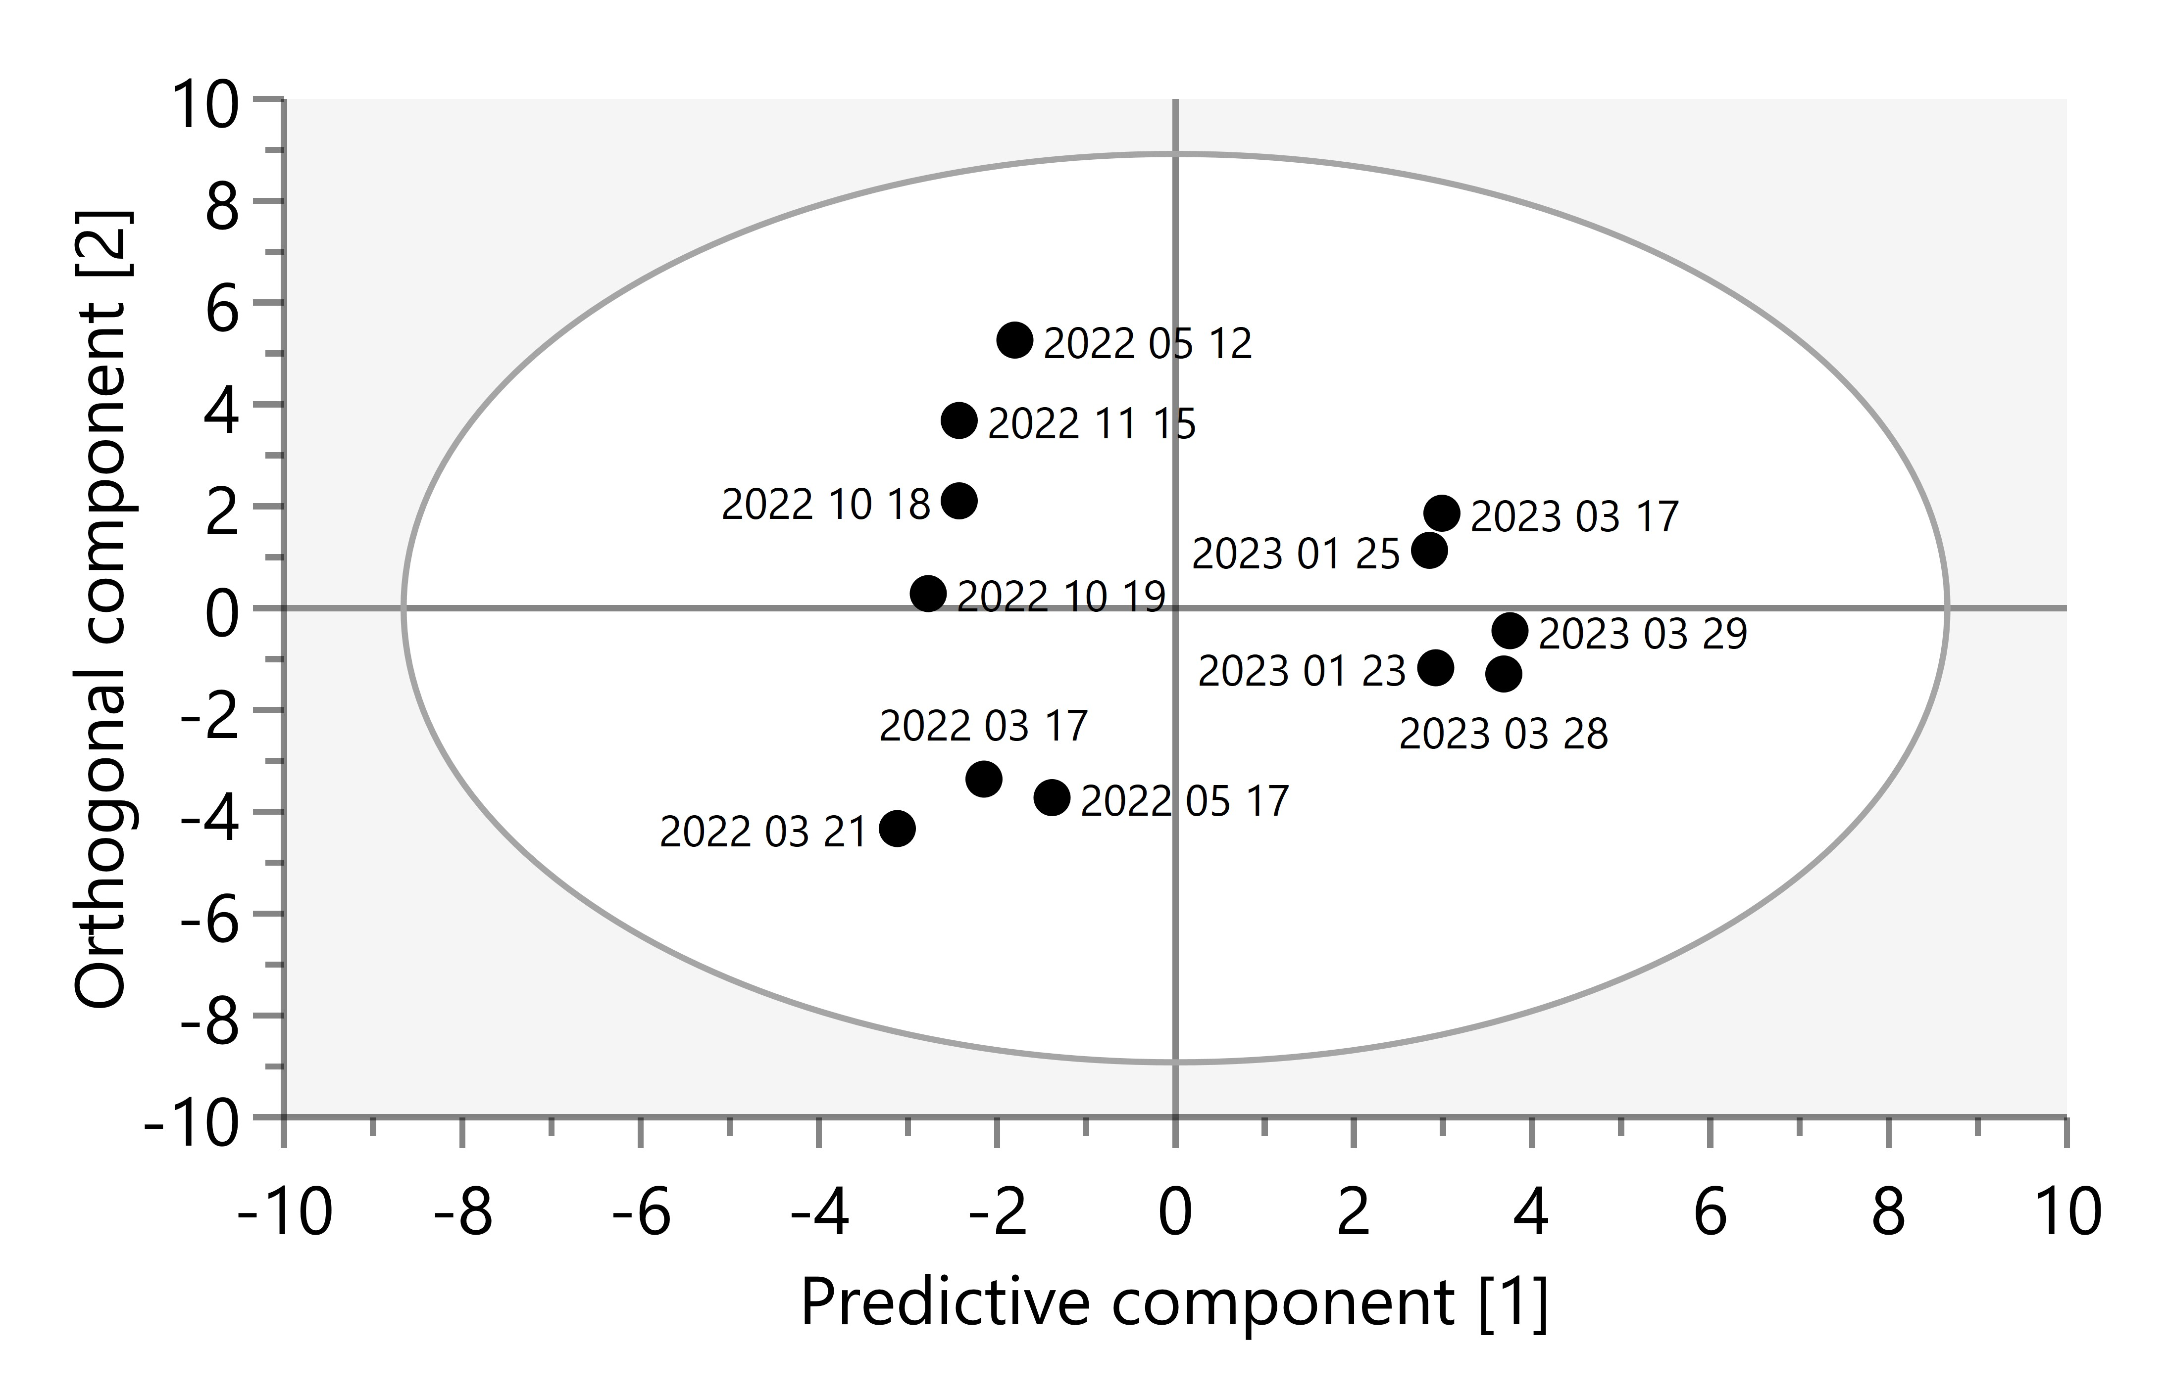
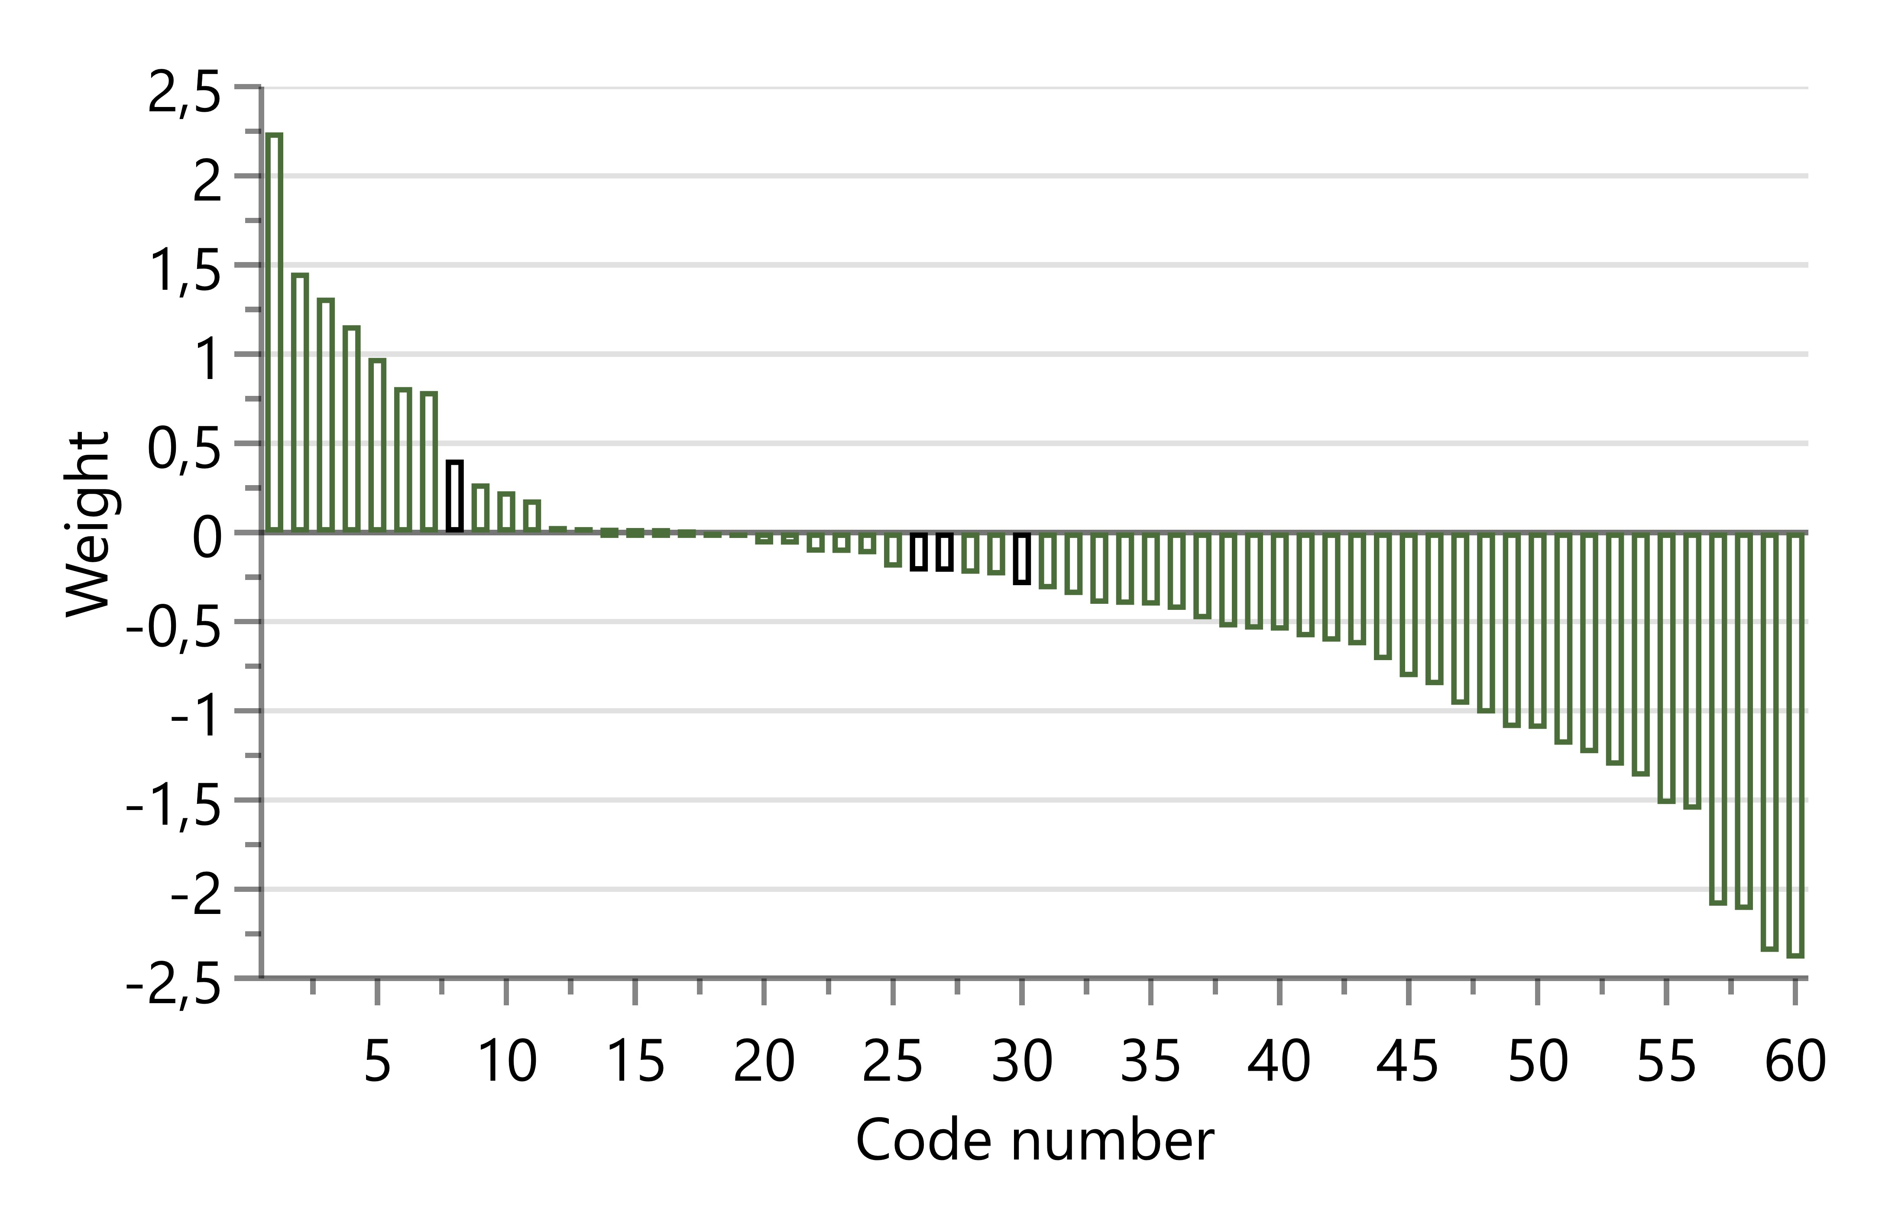
Figure 1. Left: Score plot showing temporal group affiliation of the individual lessons and similarities and differences between individual lessons in terms of code occurrences. Right: Contribution plot illustrating relative contribution of codes to the separation of 2022 and 2023 lessons. Codes with weights > 0.5 are listed in Table 1.

Changes in the teacher’s FA practice (RQ 1)
The OPLS-DA data analysis (Figure 1 and Table 1) furnishes specific insights into the shifts within Lisa's classroom practices. Notably, towards the end of the study (2023) Lisa increasingly elicited information concerning students’ needs, instead of merely checking that they had understood what the task was about (Codes 4, 50, 54 in Table 1). Her feedback also became more prominently grounded in addressing students’ learning needs (Codes 1, 59, 60), and more often requiring the students to construct reasoning that is mathematically founded (Codes 1, 5). Additionally, it was evident that Lisa, towards the end of the study, incorporated more feedback in the form of hints and prompts (Codes 1, 2, 5).

Changes in student engagement with the feedback process (RQ 2)
In 2023, students were more engaged in elaborate reasoning during their interactions with the teacher and described specific gaps in their understanding (Codes 3, 7). In contrast, in 2022 students’ engagement with the feedback process was simpler in character, often consisting of short answers—such as “five”— (Codes 55, 58). Students were also more likely to seek affirmation that they were ´doing´ the mathematics correctly (Code 57), and describing the task and what they have done on the task so far (Codes 40, 43), rather than explaining their reasoning. Instances where students did not understand the teacher’s feedback were also more widespread (Code 53).
Table 1. Descriptions of codes of teacher practice and student engagement. Only codes with substantial influence on group separation are displayed. Variables with absolute weights below 0.5 are omitted for brevity. TE denotes teacher elicitation, TF teacher feedback, and S student engagement with the feedback process.
No. | Descriptions | No. | Descriptions
Codes with higher representation in the 2023 lessons (falling order of significance)
1 | TF: Hint that requires student to construct mathematically founded reasoning. Difficulty addressed. | 2 | TF: Suggests a next step in a solution. Unclear relation to student difficulty. Does not require student to construct mathematically founded reasoning.
3 | S: Elaborate partially correct answer | 4 | TE: Asks about student difficulty
5 | TF: Hint that requires student to construct mathematically founded reasoning. Difficulty not addressed. | 6 | TF: Indicates/states the answer is wrong. Difficulty not addressed.
7 | S: Describes their difficulty
Codes with higher representation in the 2022 lessons (falling order of significance)
60 | TF: Confirms correct response. Difficulty not addressed. | 59 | TF: Funnelling. Difficulty not addressed
58 | S: Short incorrect answer | 57 | S: Asks if solution is correct
56 | S: Silence | 55 | S: Short correct answer
54 | TE: Checks task understanding | 53 | S: Does not understand the feedback
52 | TF: Praise strategy choice/implementation | 51 | TF: Describes in what way the answer is wrong. Difficulty addressed.
50 | TE: Ignores/does not notice student’s need description | 49 | TF: Indicates/states the answer is wrong. Unclear relation to student difficulty.
48 | TF: Funnelling connected to student difficulty. | 47 | TF: Describes solution algorithm. Difficulty not addressed.
46 | TF: Describes in what way the answer is wrong. Unclear relation to student difficulty. | 45 | TF: Describes solution algorithm. Difficulty addressed.
44 | TF: Praises thoroughness of work | 43 | S: Describes the task
42 | S: Recalls solution algorithm | 41 | TF: Confirms correct response. Difficulty addressed.
40 | S: Describes prior work on task | 39 | S: Short partially correct answer

Discussion
In this study, Lisa received individualised professional development support incorporating features known to be critical to generate changes in teachers’ FA practices (Andersson & Palm, 2018; Heitink, et al., 2016). The results show that she used this support to make substantive shifts in her FA practice, reshaping the interactional dynamics of the classroom. In 2022, her feedback was predominantly corrective, guiding students toward a “correct” problem-solving procedure without systematically drawing on evidence of their learning needs. Over time, however, her feedback became increasingly attuned to those needs, more frequently taking the form of hints, prompts, and questions that required mathematically founded reasoning. This shift provided students with greater opportunities for deep cognitive engagement and encouraged them to articulate the difficulties they encountered and to make their reasoning explicit.
The instructional changes were mirrored in students’ corresponding shifts in students’ engagement with feedback. In 2022 students tended to offer brief answers, seek confirmation of correctness (of their answer or method), or remain silent in response to feedback. By 2023, however, they more frequently produced elaborated explanations and explicitly described gaps in their understanding. Such behaviour suggests a shift from viewing mathematics primarily as “task completion” toward treating it as a process of reasoning and sense-making.
The reciprocal alignment between teacher practices and student engagement with the feedback process highlights a core principle of FA described by Black and Wiliam (2009): effective FA depends not only on the teacher’s ability to generate evidence of learning but also on students’ capacity to interpret and act on that evidence. Lisa’s increasing emphasis on eliciting students’ reasoning—and providing feedback in the form of hints that enabled students to build on their existing thinking—appears to have supported the dialogic nature of FA, allowing students to participate more productively in the feedback process.
The relationship observed here resonates with findings from Bishop (2021), Ing et al. (2015), and Palmberg et al. (2024), although our study focussed specifically on individual teacher-student interactions during task solving and its reciprocal nature, a context less emphasised in previous work. Bishop (2021), studying whole-class instruction, found that the intellectual work demanded by the teacher was associated with the level of intellectual work students contributed. Similarly, Ing et al. (2015) reported that when teachers elicited students’ thinking in whole-class and small-group settings, students provided more detailed explanations, and engaged more productively with peers’ reasoning. Finally, Palmberg et al. (2024), investigating whole-class FA, showed that when FA was developed in ways that positioned both teacher and students as proactive agents, the students to a larger extent than before initiated and maintained learning activities without the teacher telling them to, self-assessed and acted on those assessments, asked the teacher to provide more instruction, and asked fewer but more elaborate questions.
The present study extends this body of work by demonstrating that FA can positively influence compulsory school students’ engagement with feedback specifically in one-to-one task solving situations in mathematics. Also, it illustrates the kinds of shifts in student engagement that may occur when FA practices develop along certain dimensions and shows how these changes align with theoretical expectations and findings from other instructional settings in mathematics education.

Limitations and future research
This study offers novel insights into how changes in teaching practice may relate to student engagement with the feedback process, but several limitations should be noted. Our approach is limited in that teacher practice at a specific point in time during a lesson is not directly linked to student engagement with that particular feedback process. Instead, how much time each agent spends on certain behaviours during each lesson are aggregated at the lesson level. In addition, the use of only inductive coding of student engagement limits the specificity of connections to previous research, and the study design (with changes of one teacher and her class) naturally constrains the generalizability of the conclusions.
Future research could extend this work in several ways. The use of OPLS-DA proved valuable for analysing complex interaction data, and future studies might apply this statistical method to data with codes where the teacher practice and student engagement is connected on a more detailed level than the lesson. This could for example be achieved through an analysis producing codes for larger chunks of the interaction, where teacher feedback and student engagement are directly connected. Including more teachers and students would provide clearer evidence of generalizability. Finally, although embedding feedback in FA appears promising, comparative studies of alternative approaches to promoting engagement with the feedback process could help shed further light on this relatively new area of research.

References
Andersson, C., Boström, E., and Palm, T. (2017) Formative Assessment in Swedish Mathematics Classroom Practice. Nordic Studies in Mathematics Education 22(1), 5–20. https://doi.org/10.7146/nomad.v22i1.148754
Andersson, C., & Palm, T. (2018). Reasons for teachers’ successful development of a formative assessment practice through professional development—a motivation perspective. Assessment in Education: Principles, Policy & Practice, 25(6), 576–597. https://doi.org/10.1080/0969594X.2018.1430685
Bishop, J. P. (2021). Responsiveness and intellectual work: Features of mathematics classroom discourse related to student achievement. Journal of the Learning Sciences, 30(3), 466–508. https://doi.org/10.1080/10508406.2021.1922413
Black, P., & Wiliam, D. (2009). Developing the theory of formative assessment. Educational Assessment, Evaluation and Accountability, 21, 5–31. https://doi.org/bsqbf2
Boesen, J., Helenius, O., Bergqvist, E., Bergqvist, T., Lithner, J., Palm, T., Palmberg, B. (2014), Developing Mathematical Competence: From the Intended to the Enacted Curriculum. Journal of Mathematical Behavior, 33, 72–87. https://doi.org/10.1016/j.jmathb.2013.10.001
Braun, V., & Clarke, V. (2006). Using thematic analysis in psychology. Qualitative research in psychology, 3(2), 77–101. https://doi.org/10.1191/1478088706qp063oa
Bylesjö, M., Rantalainen, M., Cloarec, O., Nicholson, J. K., Holmes, E., & Trygg, J. (2006). OPLS discriminant analysis: combining the strengths of PLS‐DA and SIMCA classification. Journal of Chemometrics: A Journal of the Chemometrics Society, 20(8–10), 341–351. https://doi.org/10.1002/cem.1006
Heitink, M.C., Van der Kleij, F.M., Veldkamp, B.P., Schildkamp, K., & Kippers, W. B. (2016). A systematic review of prerequisites for implementing assessment for learning in classroom practice. Educational Research Review, 17, 50–62. https://doi.org/gf5z3k
Hiebert, J., Gallimore, R., Granier, H., Bogard Givvin, K., Hollingsworth, H., Jacobs, J., Miu-Ying Chui, A., Wearne, D., Smith, M., Kersting, N., Manaster, A., Tseng, E., Etterbeek, W., Manaster, C., Gonzales, P., Stigler, J. (2003), Teaching Mathematics in Seven Countries: Results from the Timss 1999 Video Study. Washington, DC: DIaNe Publishing.
Ing, M., Webb, N. M., Franke, M. L., Turrou, A. C., Wong, J., Shin, N., & Fernandez, C. H. (2015). Student participation in elementary mathematics classrooms: the missing link between teacher practices and student achievement? Educational studies in mathematics, 90(3), 341–356. https://doi.org/10.1007/s10649-015-9625-z
Jacobs, V.R., Empson, S.B., Jessup, N.A., Dunning, A., Pynes, D.A., Krause, G., & Franke, T.M. (2022). Profiles of teachers’ expertise in professional noticing of children’s mathematical thinking. Journal of Mathematics Teacher Education, 1–30. https://doi.org/10.1007/s10857-022-09558-z
Lithner, J. (2008), A research framework for creative and imitative reasoning, Educational Studies in Mathematics, 67(3), 255–276. https://doi.org/10.1007/s10649-007-9104-2
Palm, T., Andersson, C., Boström, E. & Vingsle, L. (2017). A review of the impact of formative assessment on student achievement in mathematics. Nordic Studies in Mathematics Education, 22(3), 25–50. https://doi.org/10.7146/nomad.v22i3.148889
Palm, T., Andersson, C., Palmberg, B., & Winberg, M. (2023). Mechanisms underlying effects of formative assessment on student achievement: A proposed framework to ignite future research. CADMO, 2, 9–20. https://doi.org/10.3280/CAD2023-002002
Palmberg, B., Granberg, C., Andersson, C., & Palm, T. (2024). A multi-approach formative assessment practice and its potential for enhancing student motivation: a case study. Cogent Education, 11(1). https://doi.org/10.1080/2331186X.2024.2371169
Patall, E. A. (2024). Agentic engagement: Transcending passive motivation. Motivation Science, 10(3), 222. https://doi.org/10.1037/mot0000332
Van der Kleij, F. M., & Lipnevich, A. A. (2021). Student perceptions of assessment feedback: A critical scoping review and call for research. Educational assessment, evaluation and accountability, 33(2), 345–373. https://doi.org/10.1007/s11092-020-09331-x
Winstone, N. E., Nash, R. A., Parker, M., & Rowntree, J. (2017). Supporting learners' agentic engagement with feedback: A systematic review and a taxonomy of recipience processes. Educational psychologist, 52(1), 17–37. https://doi.org/10.1080/00461520.2016.1207538
Wisniewski, B., Zierer, K., & Hattie, J. (2020). The power of feedback revisited: A meta-analysis of educational feedback research. Frontiers in psychology, 10, 487662. https://doi.org/10.3389/fpsyg.2019.03087
Yao, Y., Amos, M., Snider, K., & Brown, T. (2024). The impact of formative assessment on K-12 learning: a meta-analysis. Educational Research and Evaluation, 29(7–8), 452–475. https://doi.org/10.1080/13803611.2024.2363831

