Cohesion and tension in task design: Students working with multimodal tasks

Helena Johansson¹, Malin Norberg², and Magnus Österholm^{1,2}

¹Mid Sweden University, ²Umeå University
This presentation focuses on mathematics tasks that challenge students, which have proven beneficial for learning. Tension (as an opposite to cohesion) between different modes (e.g., words, symbols) can create such challenge. By using cohesion and tension as concepts to analyse students’ work on multimodal tasks, this study aims to identify characteristics in the task design that make students develop understanding of the mathematics concept in focus. Preliminary results show that a high degree of cohesion can direct the attention of students to the intended tension. Also, the tension in a task, although relevant, can be too challenging for students, thus ignored, and make students rely too much on previous knowledge.

Introduction
An important question in mathematics education is what characteristics a task or student activity can have to be favourable for student learning. However, there are many different types of characteristics that may be relevant to focus on. This study focuses on one such characteristic: that an activity benefits from containing some kind of challenge for the student. This characteristic is highlighted as important in various types of research.
For example, mathematics education research shows benefits from the presence of productive struggle, that is, “that students expend effort to make sense of mathematics, to figure something out that is not immediately apparent” (Hiebert & Grouws, 2007, p. 387). There is also research that focuses on similar issues concerning relationships between different modes (i.e., different resources for communication, such as words, symbols, and pictures). In multimodal situations there is a need for (a reasonable level of) a kind of tension between different modes (Engebretsen, 2012). Tension refers to a perceived discontinuity and potential contradiction between different parts, which can be seen as the opposite of cohesion. A tension creates engagement from the person who experiences the tension, while cohesion creates a sense of similarity and continuity.
In this ongoing study, we use the concepts of tension and cohesion as analytical tools to analyse students’ work with tasks that contain a mixture of different modes. The purpose of the study is to understand more about how task design, regarding cohesion and tension, relates to students’ handling of the task and their potential learning. We intend to answer the following research questions:
1. What makes students (not) pay attention to an intended tension?
2. How do students deal with an emerging tension?
The questions focus on relations between characteristics of tasks and actions of students.
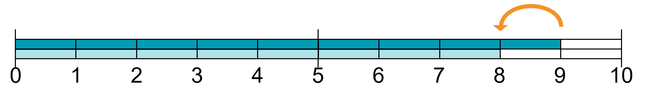
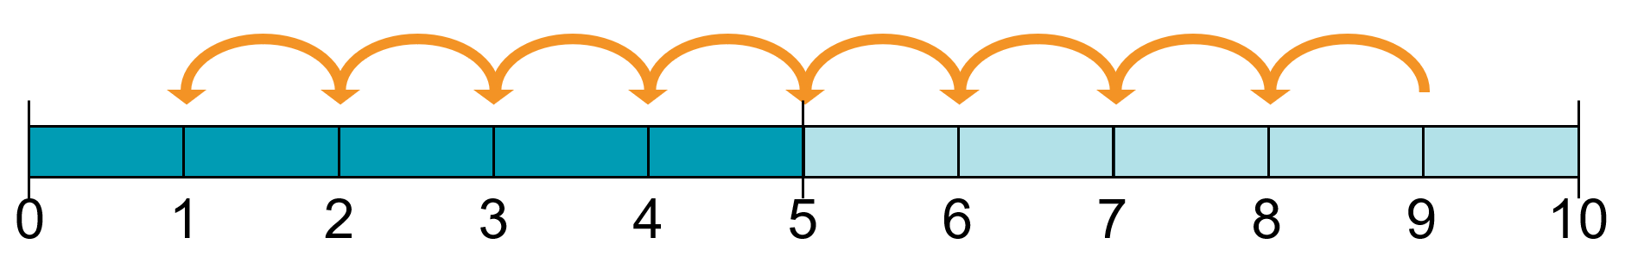
Figure 1. Illustration of 9-8 as take away (left) and comparison (right).

Method
This paper is delimited to one task about subtraction, which is created with the intention to cause tension for students by showing two different meanings of subtraction simultaneously through illustrations on number lines (see Fig 1). It is less common for students to encounter the meaning of subtraction as comparison than the meaning of take away (Norberg, 2021). There should therefore be opportunities for students to experience tension and develop their knowledge, to (better) understand the different meanings of subtraction. We first tested one version of the task with some students and then changed the design of the task based on this data, to test a new version with some other students.
Students’ work in pairs was video-recorded and analysed by first noting if/when the two different meanings of subtraction were addressed. Exploratory analyses then focused on what the students do and what in the task is focused on when different meanings of subtraction are handled, or how they “avoid” addressing the different meanings.

Tentative results and conclusions from ongoing analyses
The first version of the task presented two number lines, where the same subtraction was illustrated as take away on one number line and as comparison on a another (double) number line. Students did not experience any tension, since they “reinterpreted” the illustration of comparison to also be a description of (a started) take away, for example, by adding arrows to the illustration so it could be seen more directly as take away.
The second version had a higher degree of cohesion, since we created a context, with two students who count in different ways. We also changed from static illustrations to animations. Students then experienced a tension, regarding contradictions between the two illustrations. But it was difficult for them to resolve this tension, since subtraction as take away was used in the interpretation of the calculation based on comparison.
Our analyses show how a high degree of cohesion, as a characteristic to focus on in task design, can direct the attention of students to the intended tension. We also see the potential of creating a relevant type of tension in a task, but how this can create a too large struggle for the students, when relying too much on previous knowledge.

References
Engebretsen, M. (2012). Balancing cohesion and tension in multimodal rhetoric. An interdisciplinary approach to the study of semiotic complexity. Learning, Media and Technology, 37(2), 145-162.
Hiebert, J., & Grouws, D. (2007). The effects of classroom mathematics teaching on students’ learning. In J. Kilpatrick, G. Martin, J. Hiebert, & D. Grouws (Eds.), Second handbook of research on mathematics teaching and learning (pp. 1293-1312). Info Age Publishing.
Norberg, M. (2021). Exercise design in mathematics textbooks: The case of subtraction. Nordic Studies in Mathematics Education, 26(1), 5–30.

