Teaching quality during mathematics lessons

Jöran Petersson¹ and Jorryt van Bommel²

¹Malmö University, ²Karlstad University
This presentation focusses changes in elements of teaching quality during three parts of a mathematics lesson; start, middle and end. 64 grade 7 lessons were analysed using these partitions, forming a time series that shows decreasing quality for most elements (e.g., Modelling) from start to end of a lesson. Few elements showed an increase of quality (e.g., Intellectual Challenge). The structure of the lessons (whole class at start and individual work during middle and end) may partially account for a possible decrease. Even so, a decrease in quality is not desirable and implications on students’ learning are of concern.

Introduction
One way to describe teaching quality is to characterise at what levels a set of quality indicators are fulfilled (Tengberg et al., 2021). In the Protocol for Language Arts, 12 such indicators (elements) are described, such as time and behaviour management or connections to prior knowledge (Grossman, 2015; Klette et al, 2017). The composition of these elements capture ”practices proven critical to student learning” (Tengberg et al., 2021).

Method
The data are from an observational study of grade 7 mathematics in Sweden (Tengberg et al., 2021). For this study, 64 lessons were included and divided into three parts (ca. 15 minutes each). Each of the 192 partitions were coded in four levels with respect to all 12 elements. The four levels range from almost no evidence to consistent strong evidence of the specific element (Grossman, 2015).
This study views the three parts of each lesson as a timeseries with start, middle and end and explores how the indicators of quality distribute throughout these parts. A Mann–Whitney U test investigates whether the rank sum for the levels of the element increases or decreases between the lessons’ start and ending parts. A significant result indicates a change in quality level throughout the lessons. Three elements, both increasing and decreasing, are presented in this short communication to form a basis for discussion at Madif14; modelling (MOD), connection to prior knowledge (CPK), intellectual challenge (IC). MOD measures to what extent a teacher visibly enacts strategies, skills and processes focused on in class. CPK measures to what extent the teacher connects the content of the lesson to prior knowledge of the students. IC measures the intellectual challenge offered in activities and tasks students engage in.

Results
A majority of the elements showed a decrease of quality from start to end of lesson. In figure 1 this is visible for the elements CPK and MOD with statistical significance (p<0.001) from start to end for the quality indicators MOD and CPK while IC displayed a non-significant increase. The horizontal axes in figure 1 label the three parts start, middle and end of a lesson. The vertical axes label the number of lesson parts at each level, with a constant sum (192).

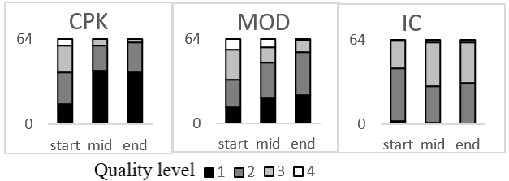
Figure 1. CPK, MOD and IC during start, middle and end of a lesson

Discussion
To obtain a level 3 or 4 for MOD, the model demonstrated must be available for most students. As most lessons follow a lesson structure with whole class instruction in the beginning and individual work in the middle and the end, level 3 will be difficult to obtain. However, some lessons scored at level 3 or 4 during these parts by gathering the class for a short whole class instruction or by instructing multiple students at a time. CPK follows a similar pattern and towards the end of the lesson only superficial references to elicit students’ prior knowledge were noticed. Here the structure of the lesson does not account for the difference as CPK can occur in talks with individual students. Finally, some increase was observed for IC where whole class instruction does not score high, whereas individual work is scored high, meaning that tasks are offered that promote analysis and interpretation. There are indications that our observed teaching quality correlates to the students’ lived teaching quality (Tengberg et al., 2021). Thus, our results might be communicated to teachers in such a way to promote a discussion around teaching quality, where small differences in instruction might have a great impact on the lived teaching quality and in extension, on students’ learning.

References
Grossman, P. (2015). Protocol for language arts teaching observations (PLATO 5.0). Center to Support Excellence in Teaching, Stanford.
Klette, K., Blikstad-Balas, M., & Roe, A. (2017). Linking instruction and student achievement. A research design for a new generation of classroom studies. Acta Didactica Norge, 11(3), 1–19. https://doi.org/10.5617/adno.554
Tengberg, M., van Bommel, J., Nilsberth, M., Walkert, M., & Nissen, A. (2022). The quality of instruction in Swedish lower secondary language arts and mathematics. Scandinavian Journal of Educational Research, 66(5), 760–777. doi:10.1080/00313831.2021.1910564

