Preschool class students’ discernment of number structure in a spatial pattern

Björklund Camillaª, Elofsson Jessicaᵇ, Kullberg Angelikaª,

Ekdahl Anna-Lena^{c}, Runesson Kempe Ulla^{c}, Alkhede Mariaª

ªUniversity of Gothenburg, ᵇLinköping university, ^{c}Jönköping University
In this paper, we present what 361 preschool class students discern of number structures in a task containing a spatial pattern. The analysis, grounded in the variation theory of learning, focuses on the students’ discernment of composite units as parts of a larger whole. To discern a task as a structure of parts and whole is presumed to be significant for what the student can do with numbers, e.g., to determine the exact number of objects in a spatial pattern. The results reveal four different ways in which students discern structures, each one with implications for the students’ abilities to determine the number of the pattern. The results induce implications for the development of mathematics teaching in preschool classes and also raise further questions for research about students’ arithmetic learning.

Introduction
In the literature on early mathematics learning, there is great interest in understanding what skills children need to develop to make use of numbers for successful problem-solving. One such skill that a coherent research field (e.g., Baroody & Purpura, 2017) points out is understanding numbers as composite units, presumably leading to the ability to use addition and subtraction strategies based on number structures. Students develop their ability to see numbers as units by distinguishing relationships within and between numbers, for example, that seven consists of three and four and that seven is three more than four (see Baroody, 1987). Seeing numbers structured in such part-whole relations further means that a student can distinguish groups of objects in a set, connections between these and how they together form a whole that can be called a number (Venkat et al., 2019). The structure is thus the underlying regularity and general principle that defines numbers, which can be recognized, for example, in spatial patterns (e.g., a three-by-four array is seen as “three groups of four” and also “12”).
Students who do not see numbers as composed units and how such units can be combined to make larger units (in a part-whole relation) have shown to suffer difficulties because they cannot make use of powerful arithmetic strategies, such as making use of “ten” as a benchmark and in particular handling multi-digit tasks (Ellemor-Collins & Wright, 2009; Neuman, 1987; Runesson Kempe et al., 2022). It is thereby necessary to gain more knowledge about young students’ understanding of numbers and relations within and between numbers. To contribute to the field of research and knowledge about young students learning about numbers, we pose the research question: In what ways do preschool class students discern number structures to determine the number of a spatial pattern? By focusing on what students discern when encountering a specific task, in terms of number structures, we might get insights into what it means to discern structures that enables determining the number of the pattern in powerful ways. This can reveal important insights to what would be necessary to focus on and facilitate the learning of in early arithmetic education, to help students learn to discern number structures.

How to determine the number of a set
Many observations are presented of how children proceed in arithmetic skills development and which strategies they use in solving problems about quantities (Fuson, 1992). Sprenger and Benz (2020) describe the development path as children first not being able to distinguish any number structures that would help them determine the quantity of a set of objects. They then learn to distinguish parts or groups of objects but cannot yet connect these to one larger unit to determine the number of the whole set. Eventually, children are able to use number structures to determine the number of the set and usually solve these kinds of tasks in a proficient way. What remains unclear in the research, however, is what makes children able or unable to use number structures.
For several decades, studies have been conducted regarding cognitive processes of determining exact numbers, an intuitive process usually called (perceptual) subitizing (Kaufmann et al., 1949; Wynn, 1998). Regardless of how objects are arranged, most people have this innate ability to recognize small numbers up to three or four without counting. When numbers are larger, people can still determine exact numbers through a process called conceptual subitizing, which means to identify smaller sets as parts of a larger set, also without counting (Clements et al., 2019). The latter process depends on learned structures (e.g., seeing a group of three and a group of four, instantly knowing they constitute a set of seven together). The ability to see a set of objects as a composite unit has shown to be of great importance for students' continued mathematics learning (Hunting, 2003; Paliwal & Baroody, 2020), not least when the number range increases and tasks contain tens and hundreds or more (Ellemor-Collins & Wright, 2009).
Research and theories about children's development of counting skills are extensive but agree that a prerequisite is children's ability to discern units, that is, that objects in the outside world can be seen as belonging to a common collection or group, which is not initially numerical in its meaning but rather has the meaning that something can belong to a certain category of objects and constitutes an indefinite "manyness" (Steffe, 1991). Experiencing patterns as numerical, on the other hand, means that it is the number of objects arranged in a certain pattern that appears to the child. This is a basis for distinguishing how groups can be seen as parts of a larger whole, that is, creating a structure.
According to Benz (2013), children can already in preschool age experience structures in quantities and use them to determine the number of sets. When students (perceptually) structure numbers (a whole) into subgroups, it implies a special ability to see wholes and parts. Schöner and Benz (2018) observed, for example, that when a student says, "Two, three, and two more is seven", the student discerns a structure based on number relationships in the form of parts that add up to 7 and can use this structure to determine the sum. It could be interpreted as the student discerning a group of two and a group of three that makes five, and five and two are seven, that is, several composite units that relate to a whole.
Previous studies have also focused on what kind of groupings students perceive. Sprenger and Benz (2020) investigated, with the help of technology that follows eye movements (eye-tracking), how 5-year-olds visually group objects when asked to determine numbers in a set. They found that the kind of grouping, and the use of structure, varied depending on the number of objects in the sets, that is, whether there were five, seven or nine objects arranged in a two-by-five array (egg carton), but also on how the objects were arranged in subitizable groups (three in one row and two in a row below, or as one row of five). Five objects placed in a row (in the egg carton) made the children use structure to a lesser extent than five objects arranged as groups of three and two. Mandler and Shebo (1982) also showed empirically that the way objects are arranged, and thus how they are perceived, matters for the certainty of determining numbers in a set.

Theoretical framework
The study we have conducted takes its starting point in variation theory of learning (Marton, 2015). Variation theory conjectures that any action, such as how a student is determining a number in a spatial pattern, is a function of what the student discerns when encountering the specific phenomenon. When we approach for instance a mathematical task, some aspects are noticed, they come to the fore of our attention, and are related. How a student handles a task (reasoning about and indicating with words and gestures what he or she discerns) can thereby be interpreted as a result of how the awareness is structured at a particular moment and what is discerned in the task. Different responses observed among students who encounter the same task, including those having difficulties, are explained in terms of them not (yet) having discerned certain aspects of the task, in our case whether units involved and relations between and within them are attended to. Simultaneous discernment of several aspects is considered to be key in the progress in students’ awareness because it liberates new ways of handling the task (this has been shown both theoretically in e.g., Marton, 2015, and empirically in e.g., Runesson, 2006; Björklund et al., 2021). This makes the theory useful for studying and interpreting qualitative different ways of encountering a task.

The study
The basis for the analysis is task-based interviews conducted with 361 preschool class students. The students are, on average, 6 years old the year they attend preschool class. The students were recruited from five different municipalities in the Southern parts of Sweden. Students’ legal guardians had given their informed consent. In this particular study, our focus is on what structures are discerned in the spatial pattern, as they appear to the students in the total data set.
The interview consisted of tasks that the students were to answer orally. A protocol was used where the researcher made notes of the students’ verbal answers and actions such as pointing, circling or gestures with fingers. Each interview took about 15 minutes. For the purpose of this paper, we have chosen one task for analysis: a spatial pattern where 12 objects are placed in 3 rows and 4 columns centred on an A4-sized paper. The student is shown the pattern (see Figure 1) and given two questions orally: a) “How can you see, how many dogs there are?” and b) “How many dogs are there, all together?”. In the task, the number of objects is more than what cognitive processes such as subitizing include, which means that the student must use some kind of strategy to determine the number of the objects, such as distinguishing structures that appear in the pattern. The vast majority of the students (95%) was able to complete the task (correct or incorrect) in one or another way, only 5% did not complete the task or their answer was not possible to interpret.

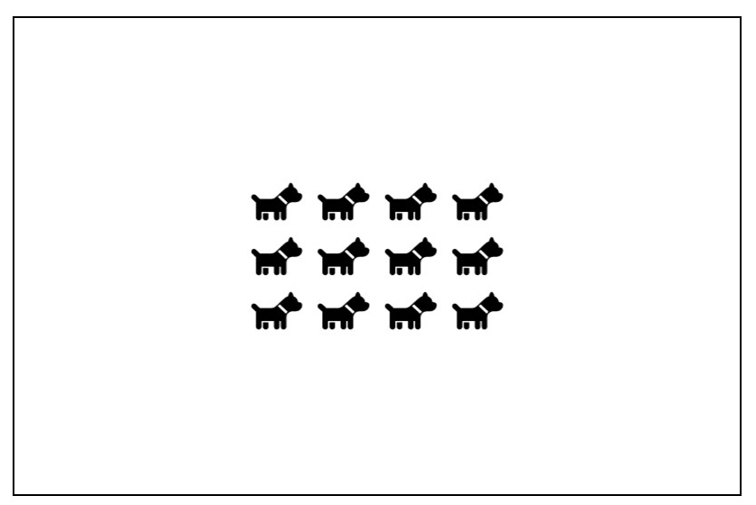
Figure 1. Task with spatial pattern (11 x 7 cm on A4 size paper) to be answered orally.

Analysis
The students' responses to the tasks in the interview were documented in a protocol with a particular focus on their choice of strategies to solve the task. The first question (question a) in the task does not ask for an exact number but focuses on possible discernment of structure, while the second question (question b) directs attention to the exact number (how many?), to assess students’ ways of making use of number structures. In the qualitative analysis, both questions are analysed as one task or phenomenon that the students respond to.
Our interest in this study was primarily directed towards what structures the students discern in the spatial pattern, which was answered qualitatively through carefully analysing notes in the protocols and field notes from the interviews. In this analysis, we took a variation theory approach, which means that we identified in what ways structures were discerned by analysing how parts (the discerned units) and the whole were discerned. For example, a student who is answering “Four, four and four” but counts all in ones to determine the total number has been interpreted as discerning units of four but they are not related to one another to make a composite whole. A student who answers “Four, eight, twelve” has on the other hand simultaneously discerned the units as parts of the larger whole and is able to complete the task, thus making use of the number structure s/he has discerned. The interpretations were made based on the students’ verbal and gestural reasoning when completing the task. In the results, we illustrate this with figures pointing out the units that the students’ express themselves discerning.

Results
In the following, the ways in which the students discern some kind of structure are described. This is related to whether the part-whole relationship is discerned by the students.
The task with the dogs was challenging, as very few students provided a correct number directly and confidently. Because the number of objects to be estimated is relatively large, the students often arrive at an answer by reasoning about subitizable groups that they point out in the pattern. The most common distinctions made were three-groups and four-groups, which is likely influenced by the fact that the pattern is structured as a three-by-four array where the groups of three or four are easily recognizable for the student and often seen as composite units. Special emphasis has been placed on whether students experience these groups as composite or individual units and whether they can discern these related to the whole. The part-whole relationship is regarded as a necessary aspect to discern in order to be able to use number structures for the purpose of determining the number of the objects in the pattern.
In the analysis, four distinct ways of discerning structures in the spatial pattern appear: composite units without relation to the whole, single units in relation to the whole, composite and single units with relation to the whole, and composite units with relation to the whole. These are identified based on how the student discerns units as parts and whole, especially the relationship between them.

Composite units without relation to the whole
First, we observed that some students only discerned parts in the spatial pattern but not a relation to the whole set of 12 objects.
When students discern composite units in the spatial pattern, such as objects in three rows of four or four columns of three in each (see Figure 2, left picture), they sometimes cannot discern how these form parts of a larger whole. This can be the student moving or pointing his finger along the columns or rows. For example, one student pointed from left to right along the rows, saying, "Three fours, then I forgot what it was, so I counted them", then counting in single units to determine the exact number of dogs. The composite units consisting of three groups of four dogs are then not related to the whole. The student thus expresses the multiplicative relationship in the pattern, but the difficulty lies in seeing how the number of groups is related to the whole. When determining the number of the objects, the student instead discerns only single units and counts them to find the whole.
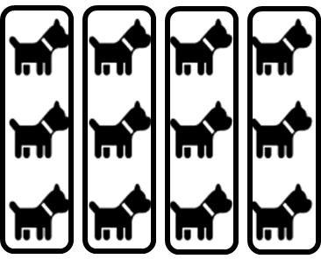
Another example is a student who discerns units of three by demarcating them within the rows of four objects (see Figure 2, right picture). Also, unable to discern how the units of three relate to a composite whole and counts in single units to determine the total number of dogs.
Figure 2. Students’ ways of discerning three-units but with no relation to the whole.

Single units in relation to the whole
Second, students may also discern single units (1) in the pattern, implying a cardinal set (whole) of 12. This is, however not made up of groups as composite units within this whole.
Quite many of the students discern single units. What distinguishes this way of seeing the spatial pattern is that the students count each object in single units, usually following one row or column at a time, to determine the number of dogs. However, no clear structure of parts and whole is used. Students experience the whole consisting of 12 single units but no composite units.

Composite and single units with relation to the whole
Third, we observed several students discerning (at least) two groups in the pattern as composite units greater than 1, forming a whole together. However, the students see the remaining objects in the pattern as single units (1) and counts on to determine the number of objects.
When students discern certain groups in the spatial pattern as composite units greater than 1, forming a whole, some use the "doubles" structure. This means that they can discern for example, 4 in two rows as 8 (the even parts relate to a whole). However, the student is unable to create additional groups of units larger than 1 to relate to a larger whole than 8, which is why the student continues counting in single units until all objects in the pattern are included in the whole 12, for example pointing at the objects in the rows while saying: "4 and 8, then 9, 10, 11, 12". This can be seen as an expression of the student discerning a structure of "four and four, which is eight" but does not have sufficient experience of how another added four-group forms part of the unfamiliar whole (see Figure 3).
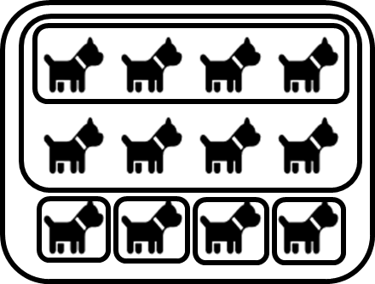
Figure 3. Student’s way of discerning two groups of four as a composite eight but remaining objects as single units within the whole set of twelve.
Different ways of grouping composite units appear in the interviews, followed by one-step counting to determine the exact number of dogs. For example, the student first puts together two or more groups, usually of the same size, and then the units that remain to be counted: "Here are nine” (covers nine dogs with his hand, then counts) “9, 10, 11, 12.” In what way the student experiences the nine dogs that are covered with the hand is not clear from the data material, however, the number is greater than a range that is possible to subitize, which is why it is likely that the student discerns some form of structure in the nine dogs (three columns of three in each) while the last column is not expressed as a composite unit but as single units that need to be counted in ones.

Composite units with relation to the whole
Finally, there were students who discerned composite units greater than 1 and related to the whole, simultaneously. The meaning of 12 for these students is a whole within which parts are included in a simultaneously discerned relationship, which helps them determine the number of objects in an effective way.
Some students give a quick and confident answer “All of them are twelve” and describe the mathematical reasoning that leads to the answer when asked to describe how they arrived at their answer “’cause it’s four and four and four”. However, fast correct answers are rarely given in this task. The students who answer quickly and correctly in this way answer the total number already when they receive the first question (“how can you see...”). The structure of the spatial pattern is simultaneously discerned as a relation between parts and whole – the number is experienced as one object. The student can differentiate parts of the whole and explain how the numbers relate to each other. Most students who answer quickly and confidently can make that differentiation when given a follow-up question. However, they do not need to start by first distinguishing separate parts to see how they form a composite whole.
Many of the students discern units of three or four in the spatial pattern and can also give the answer 12 to the question of how many there are together. They thus discern equal-sized groups forming the whole 12: “three, three, three and three. Twelve". As the rows or columns visually form units to focus on, they become prominent as parts of the whole 12. A similar way of reasoning can be seen in students who also discern units of three or four, but in a clear additive structure: "Four and four makes eight, then four again makes 12" (while pointing to the rows).
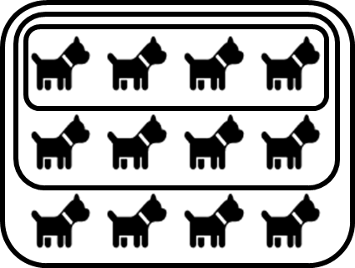
Another way of reasoning based on discerned even units involves a simultaneous addition where each part is added to the previous one to form a new whole: "four, eight, twelve" (see Figure 4), while the number grows successively in the student's reasoning in even steps that include the previously discerned composite units as a part of a new whole. This can be described as the student seeing units within units and is able to use this kind of structure to determine the number of dogs.
Figure 4. Students’ way of discerning units within units.

Discussion
In this paper we set out to investigate in what ways preschool class students discern number structures to determine the number of a spatial pattern (a three-by-four array). The qualitative analysis results in three qualitatively different ways of discerning structures based on composite units, while students who only distinguish single units that are counted in ones (1) do not have the meaning of number structure in the sense of discerning composite units in the spatial pattern. Our study has demonstrated that the discerned composite units are not necessarily related to a cohesive whole at the same time, which hinders the use of the number structures to determine the number of a set. The majority of students turn out not to be able to use number structures in a successful way to determine the number of objects, which directs attention to early mathematics education’s practices of making the part-whole relationship of numbers visible to the students, as units within units. The analysis presented here may give insights into what the teaching should emphasize because of the complex nature of discerning number structure found in this study. In particular, the importance of students being able to attend to and having both the composite units and the whole in their awareness simultaneously.
The number range could play a role in how determining the number of a set can be solved. For example, a lower number range can be memorized or recognized as a spatial pattern representing a certain number, such as dice patterns (Mandler & Shebo, 1982). A larger number range would pose a challenge because it becomes more difficult to memorize certain patterns. However, in Schöner and Benz (2018) studies, students are found to have the same difficulty in discerning parts of a whole for numbers less than ten, as we see in the larger number range up to twelve; that is, students are able to distinguish and relate composite units to a whole but then often count single units to determine the total number. The reason students can discern units but not use the number structures, therefore needs an explanation other than that the number range is too large.
Based on the observations made in the study – that some students have learned to discern units but do not use number structures – it can be concluded that the focus on the part-whole relationship is a necessary aspect, but perhaps not sufficient, for all students to use number structures to determine the number of a set. In the qualitative analysis, the whole emerges as a significant aspect where, in particular the simultaneous discernment of parts (composite units) related to the whole (a structure consisting of composite units) seems to play a role in how the students are able to determine numbers. A didactically important question then arises: whether the teaching focuses on what discerned units are parts of, or in other words, emphasizing the parts, the whole and the relations between them simultaneously. Another aspect to consider in education may be to create the conditions for the student to experience ten as a composite unit because it facilitates determining the number of larger sets, where groups of two, three or four units become a demanding procedure if clear reference points such as five or ten cannot be related to. On the other hand, the pattern in the analyzed task does not provide direct guidance to discern (five or) ten as a composite unit, which may be why very few of the students in this study could distinguish such a structure. One limitation of our study is thereby that only one task has been analyzed. Analyzing additional tasks that include different spatial patterns could provide further insights into the structuring process.
In conclusion, we argue that a dedicated focus on studying and paying attention to students’ discerning number structures in didactic research can provide valuable insights for the development of teaching that contributes not only to students' mathematics skills but also to a fundamental and deep understanding of number and how numbers can be structured to see and use relationships within and between numbers successfully.

Acknowledgements
The study was financed by the Swedish Research Council (Grant no. 2020-03712).

References
Baroody, A. J. (1987). Children’s mathematical thinking. Teachers College.
Baroody, A., & Purpura, D. (2017). Early number and operations: Whole numbers. In J. Cai (Ed.), Compendium research in mathematics education (pp. 308–354). National Council of Teachers of Mathematics.
Benz, C. (2014). Identifying quantities – Children’s constructions to compose collections from parts or decompose collections into parts. In U. Kortenkamp, B. Brandt, C. Benz, G. Krummheuer, S. Ladel, & R. Vogel (Eds.), Early mathematics learning. Selected papers of the POEM 2012 conference (pp. 189–203). Springer. https://doi.org/10.1007/978-1-4614-4678-1_12
Björklund, C., Marton, F., & Kullberg, A. (2021). What is to be learnt? Critical aspects of elementary arithmetic skills. Educational Studies in Mathematics, 107(2), 261–284. https://doi.org/10.1007/s10649-021-10045-0
Clements, D., Sarama, J., & MacDonald, B. L. (2019). Subitizing: The neglected quantifier. In A. Norton, & M. W. Alibali (Eds.), Constructing number. Research in mathematics education (pp. 13–45). Springer. https://doi.org/10.1007/978-3-030-00491-0_2
Ellemor-Collins, D., & Wright, R. B. (2009). Structuring numbers 1 to 20: Developing facile addition and subtraction. Mathematics Education Research Journal, 21(2), 50–75. https://doi.org/10.1007/BF03217545
Fuson, K. (1992). Research on whole number addition and subtraction. I D. Grouws (Eds.), Handbook of research on mathematics teaching and learning (pp. 243–275). Macmillan Library Reference.
Hunting, R. P. (2003). Part-whole number knowledge in preschool children. Journal of Mathematical Behaviour, 22(3), 217–235.
Kaufman, E. L., Lord, M. W., Reese, T. W., & Volkmann, J. (1949). The discrimination of visual number. American Journal of Psychology, 62, 498–525.
Mandler, G., & Shebo, B. J. (1982). Subitizing: An analysis of its component processes. Journal of Experimental Psychology: General, 111(1), 1–22.
Marton, F., & Booth, S. (1997). Learning and awareness. Lawrence Erlbaum.
Mulligan, J., Mitchelmore M. & Stephanou A. (2015). PASA Response Booklet 2. Australian Council for Educational Research.
Neuman, D. (1987). The origin of arithmetic skills. Acta Universitatis Gothoburgensis.
Paliwal, V., & Baroody, A. J. (2020). Cardinality principle understanding: the role of focusing on the subitizing ability. ZDM Mathematics Education 52(4), 649–661.
Runesson, U. (2006). What is it possible to learn? On variation as a necessary condition for learning. Scandinavian Journal of Educational Research, 50(4), 397–410.
Runesson Kempe, U., Björklund, C., & Kullberg, A. (2022). Single unit counting – an impediment for arithmetic learning. Research Report in C. Fernández, S. Llinares, A. Gutiérrez, & N. Planas (Eds.), Proceedings of the 45th Conference of the International Group for the Psychology of Mathematics Education (Vol. 3, pp. 363–370). Alicante, Spain: PME.
Schöner, P., & Benz, C. (2018). Visual structuring processes of children when determining the cardinality of sets—The contribution of eye-tracking. In C. Benz, H. Gasteiger, A. S. Steinweg, P. Schöner, H. Vollmuth, & J. Zöllner (Eds.), Early mathematics learning— Selected papers from the POEM Conference 2016 (pp. 123–143). Springer.
Sprenger, P. & Benz, C. (2020). Children’s perception of structures when determining cardinality of sets—results of an eye‑tracking study with 5‑year‑old children. ZDM Mathematics Education, 52(4), 753–765. https://doi.org/10.1007/s11858-020-01137-x
Steffe, L. P. (1991). Operations that generate quantity. Learning and individual differences, 3(1), 61–82.
Venkat, H., Askew, M., Watson, A., & Mason, J. (2019). Architecture of mathematical structure. For the Learning of Mathematics, 39(1), 13–17.
Wynn, K. (1998). Psychological foundations of number: Numerical competence in human infants. Trends in Cognitive Sciences, 2(8), 296–303.

The task is inspired by Mulligan, Mitchelmore and Stephanou (2015)

